**BUILDING A FACE DETECTION APP ON AWS**

**By**

**ETHNUS**



**NAME : K. VISHNU VARDHAN**

**DEGREE : M.Tech (VLSI DESIGN)**

**COLLEGE : VIT VELLORE**

**PART 1 SCREENSHOTS (AWS)**

1. **AWS LOGIN SCREEN WITH USERNAME:**

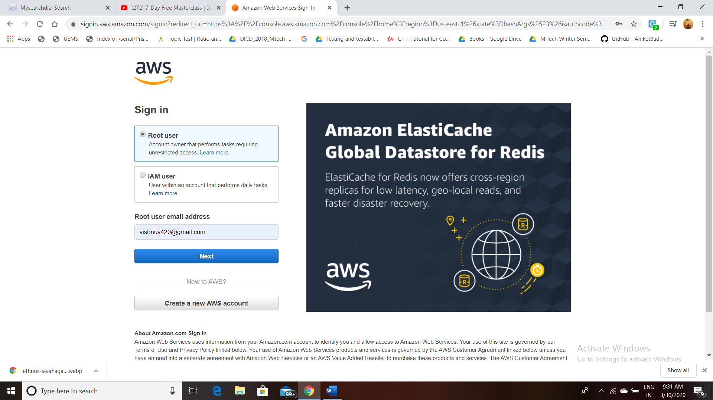

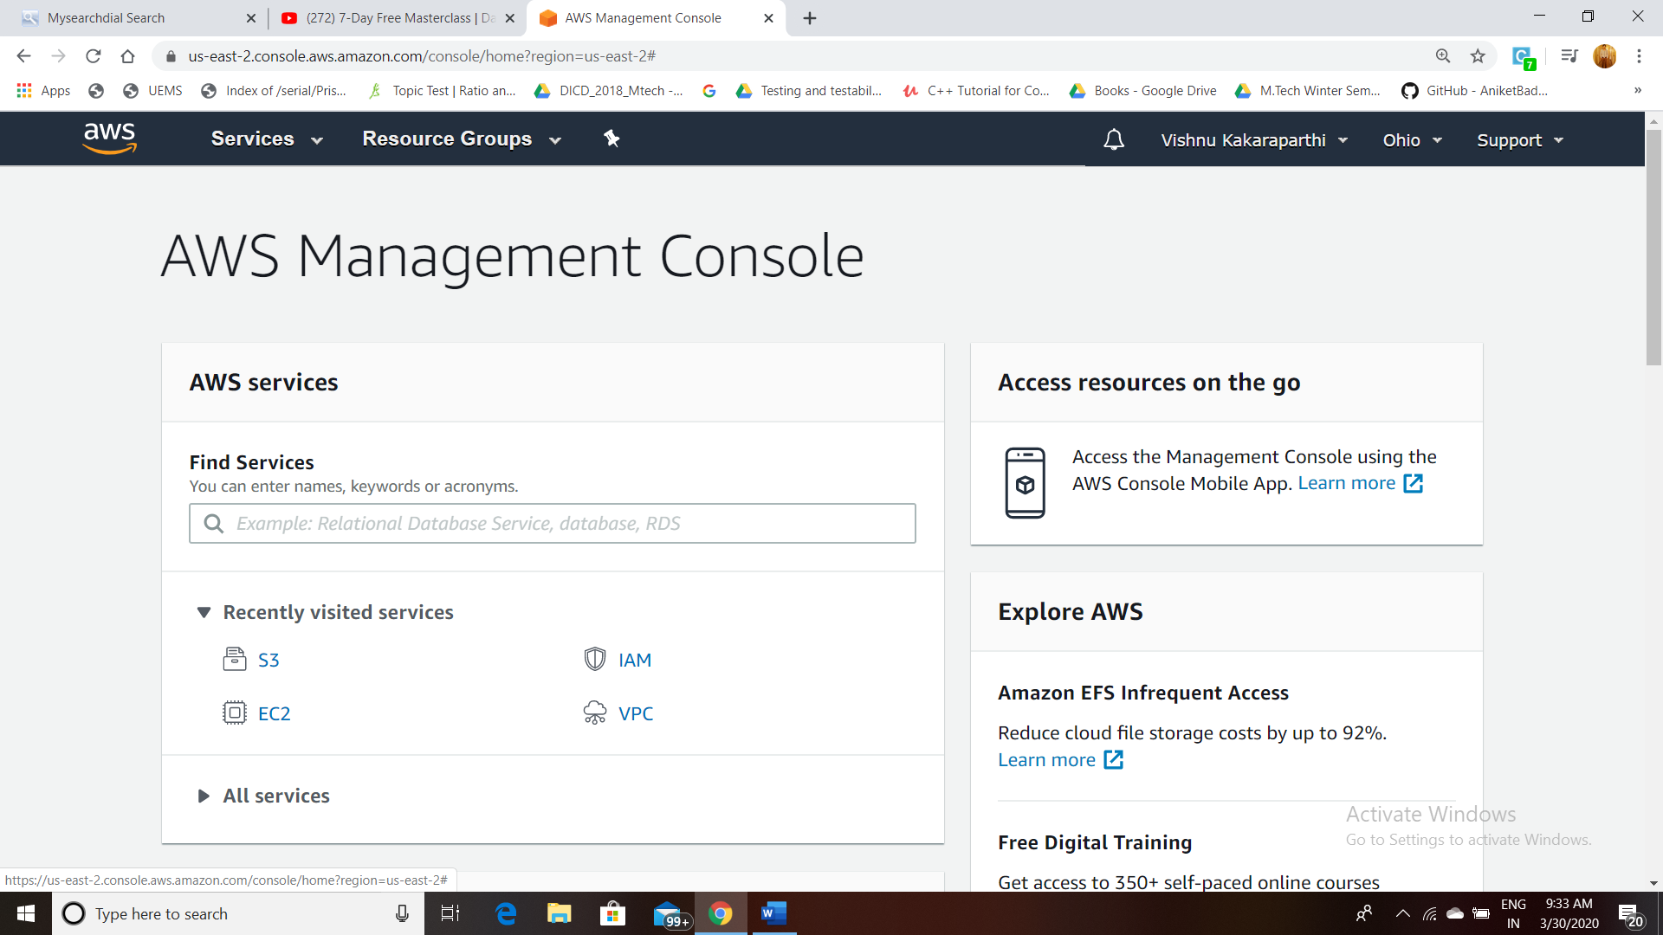

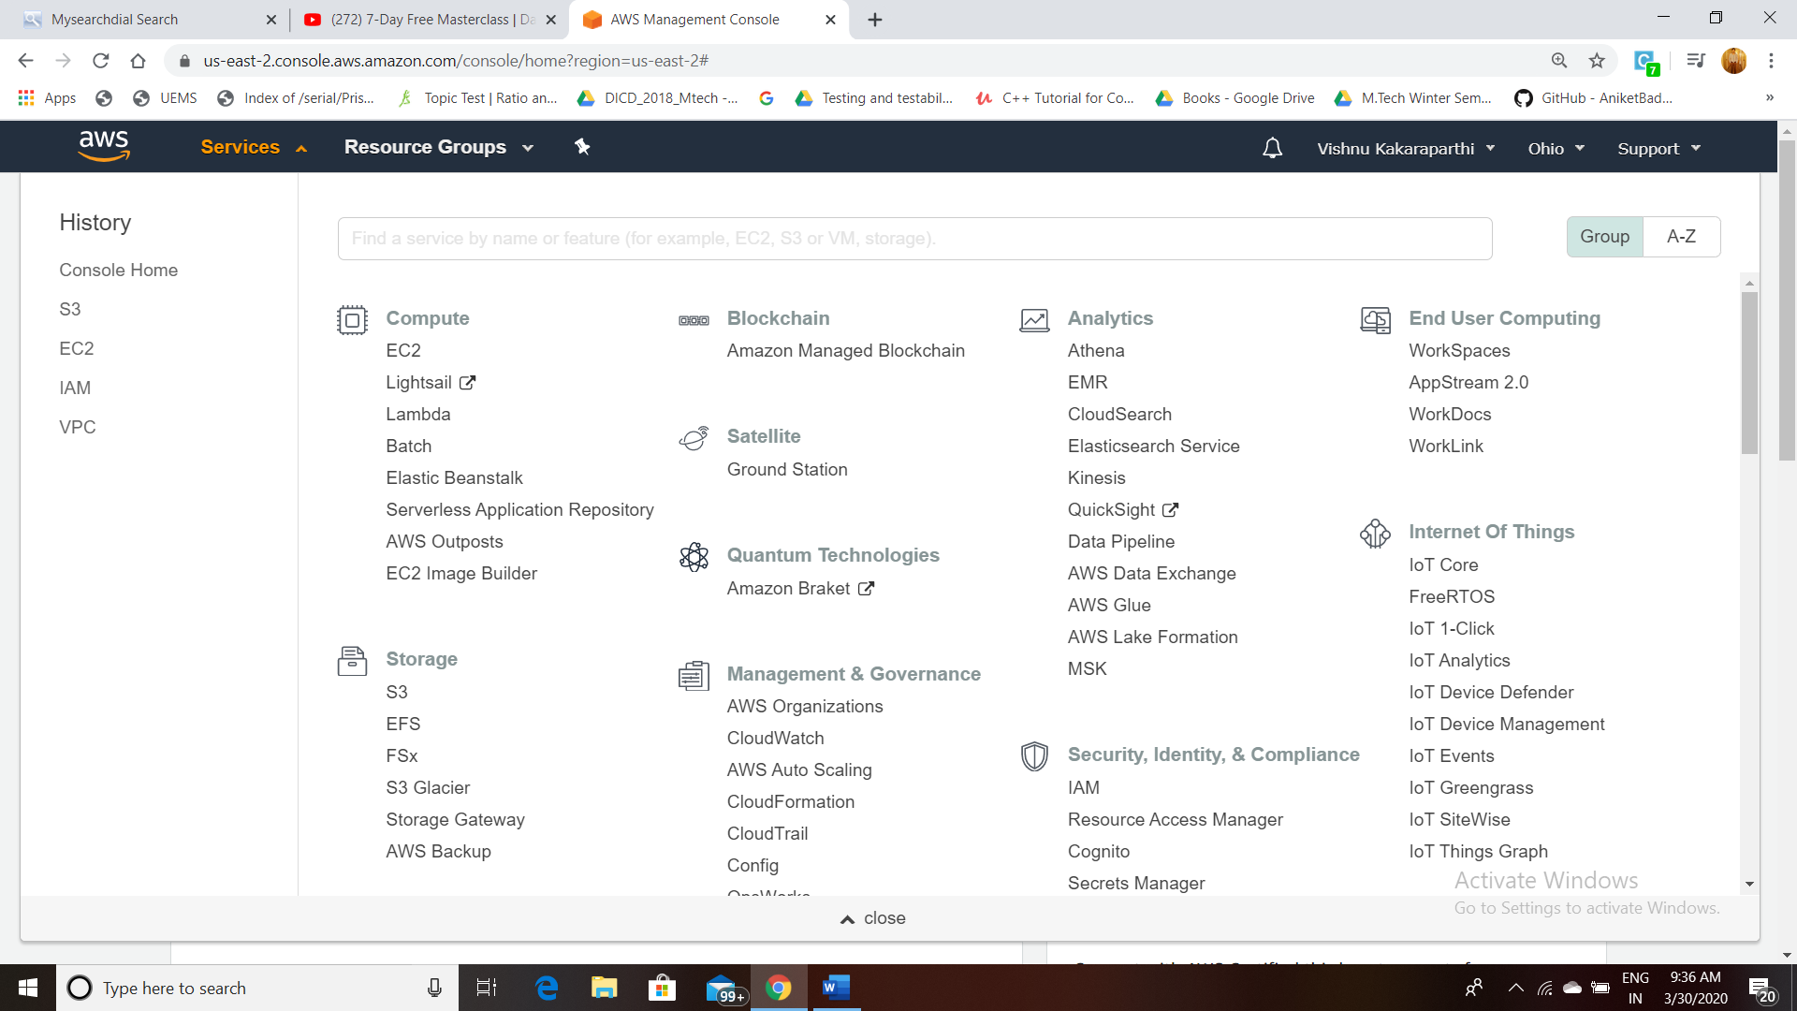

1. **EC2 DASHBOARD:**

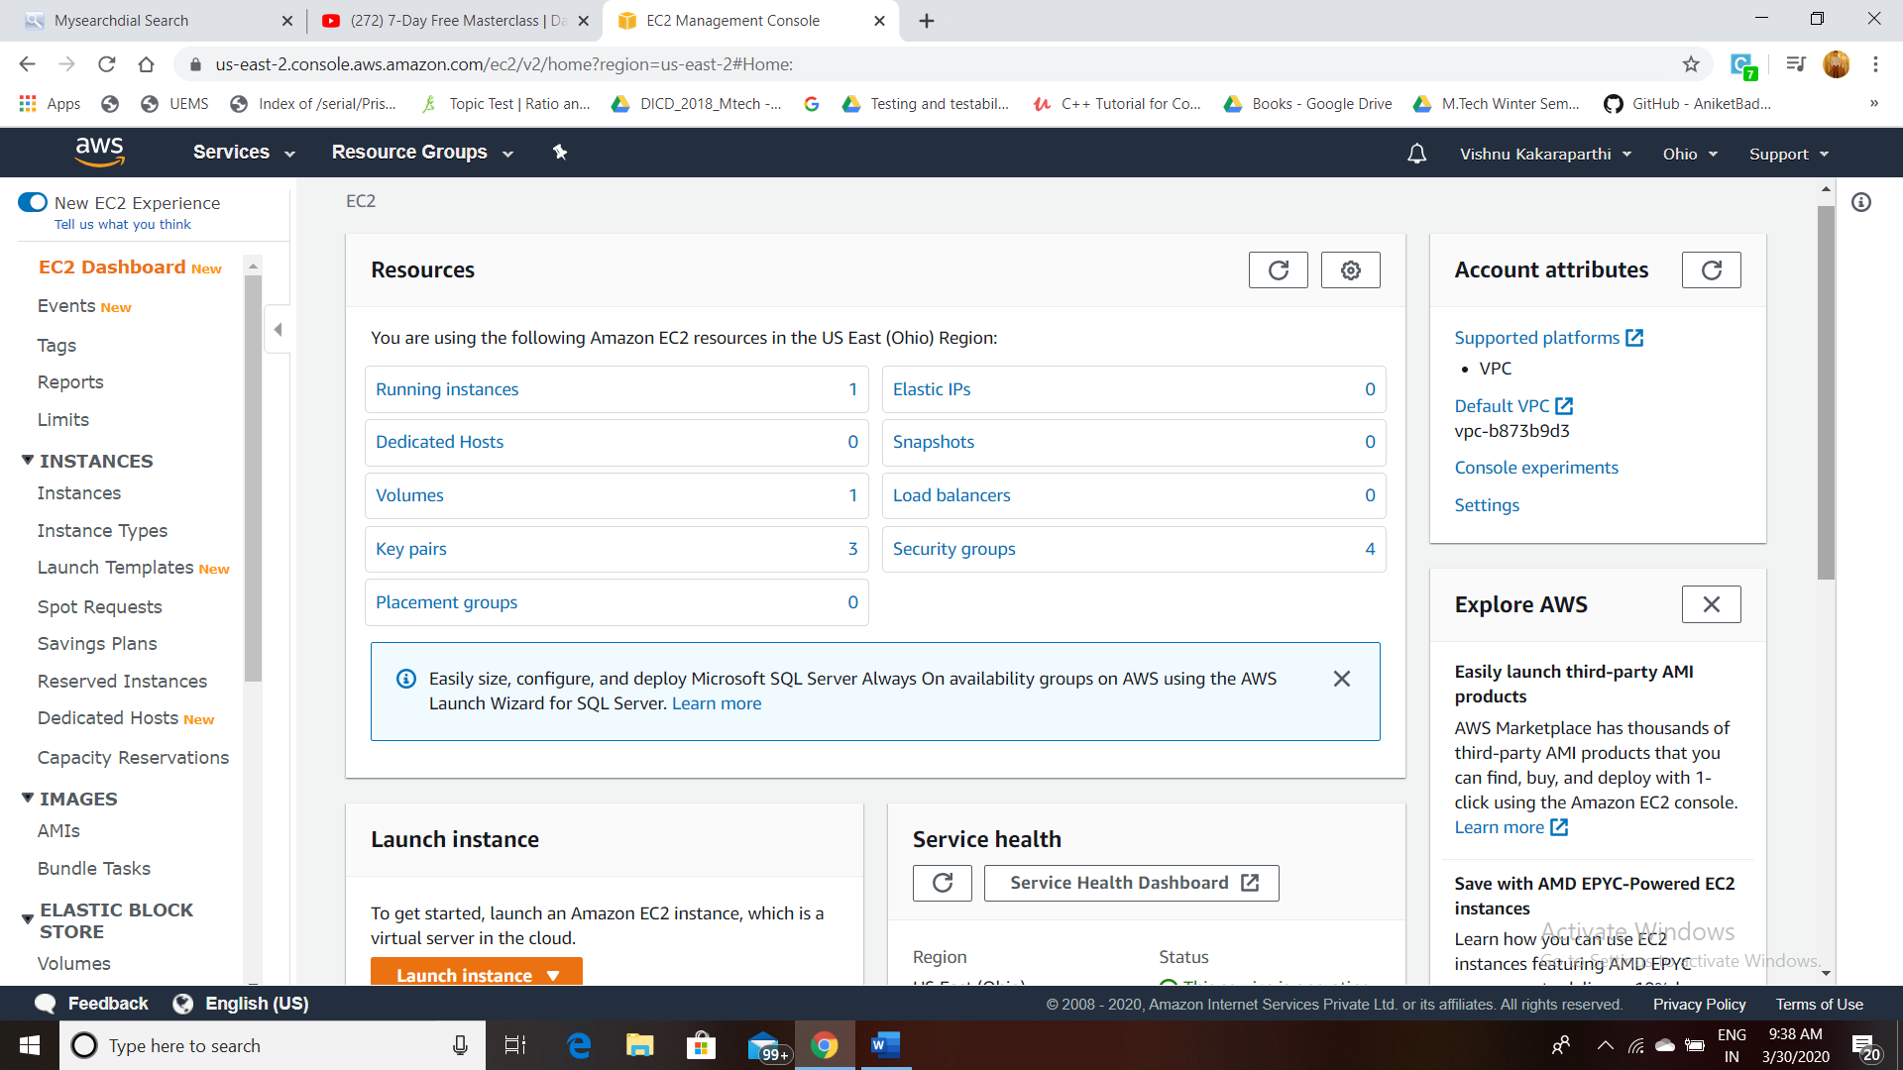

1. **S3 DASHBOARD:**

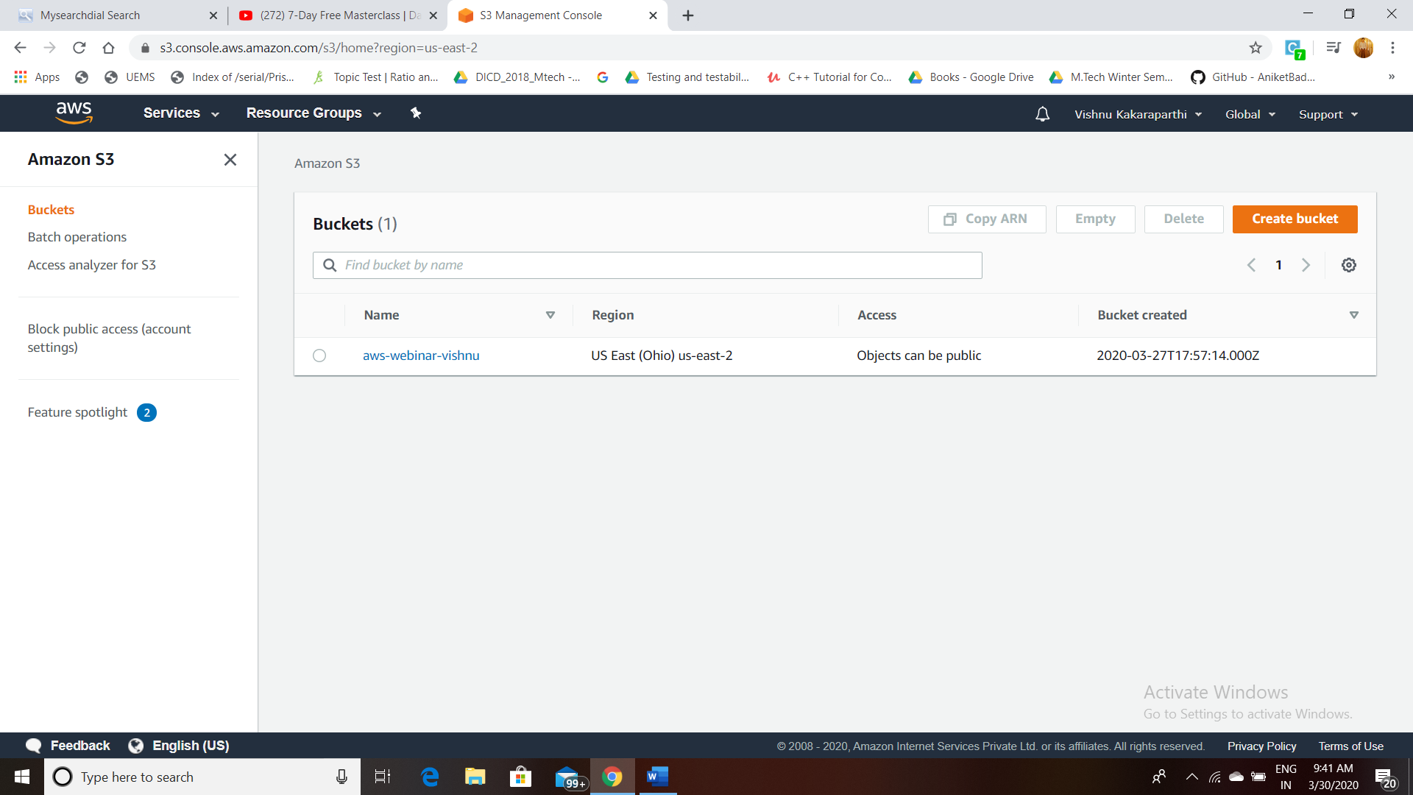

**D: REKOGNITION DASHBOARD:**

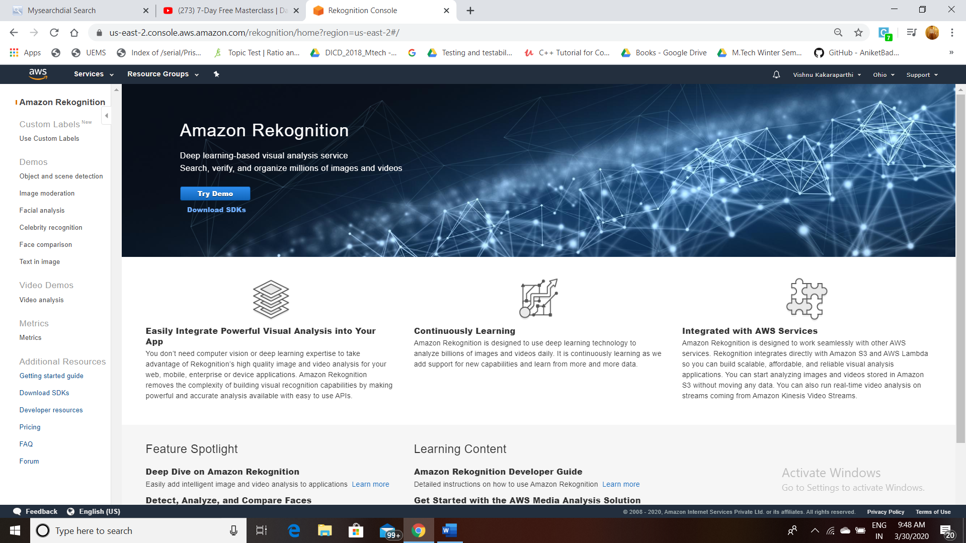

**PART2 SCREENSHOTS (EC2)**

1. **STEP 1: To Launch INSTANCE**

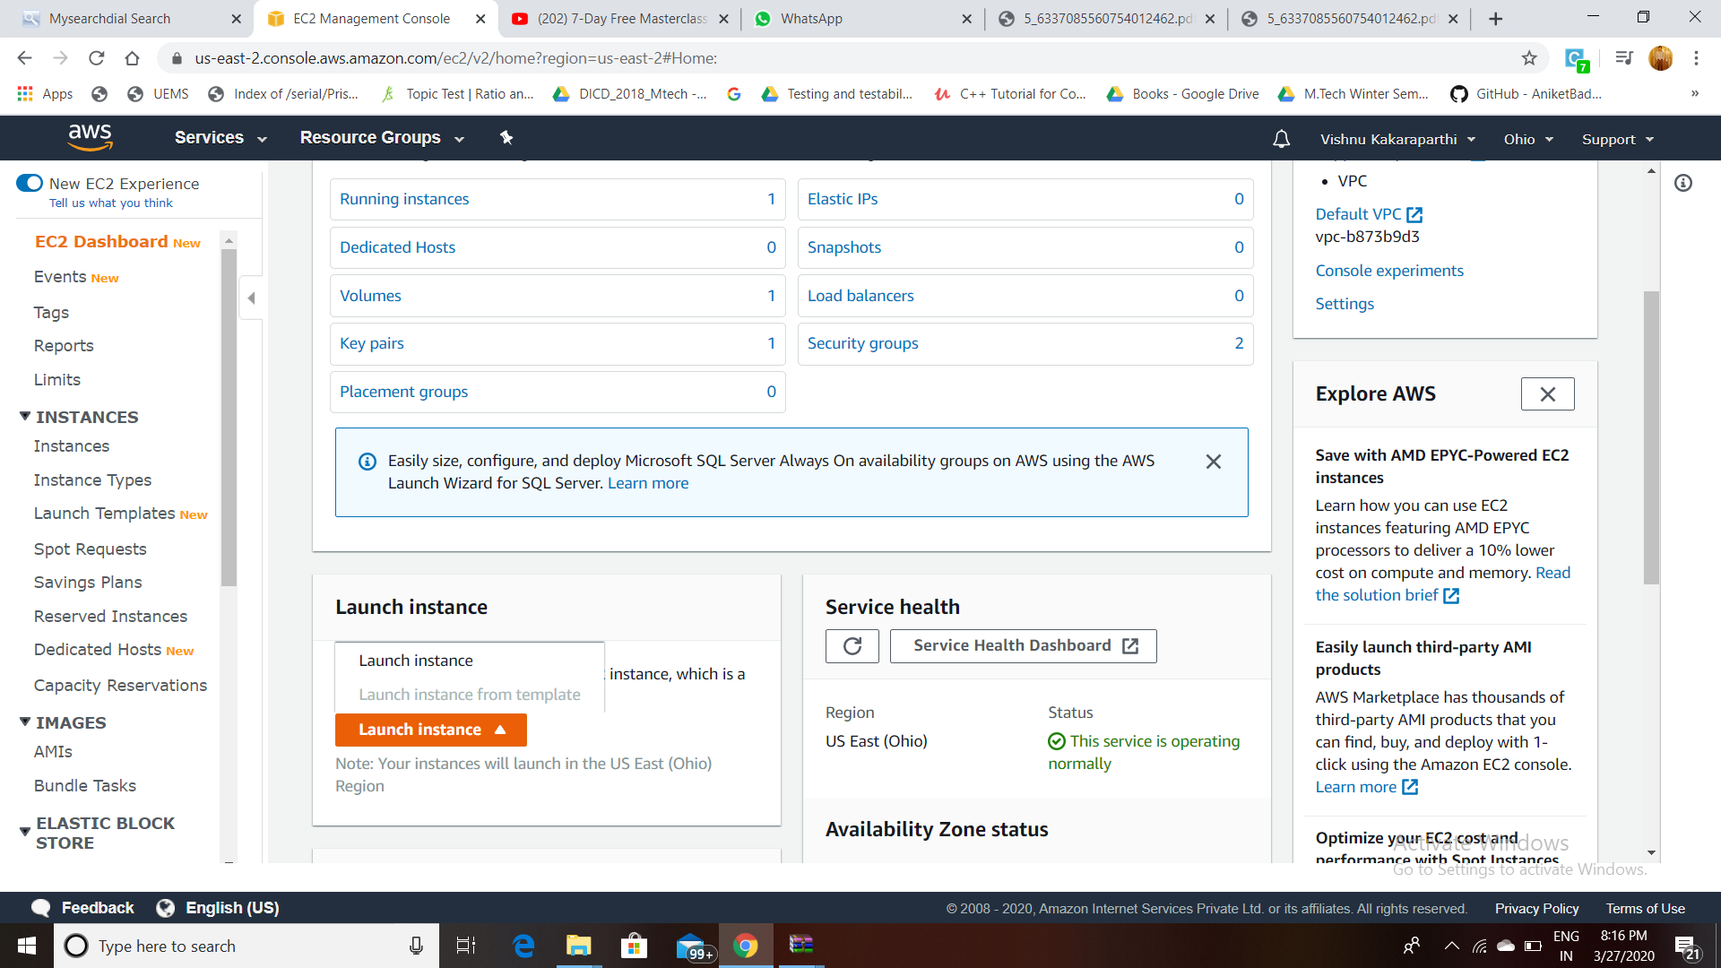

1. **STEP 2: CHOOSING An AMI**

**Selecting Amazon Linux 2 AMI(HVM) SSD Volume Type (64 bit)**

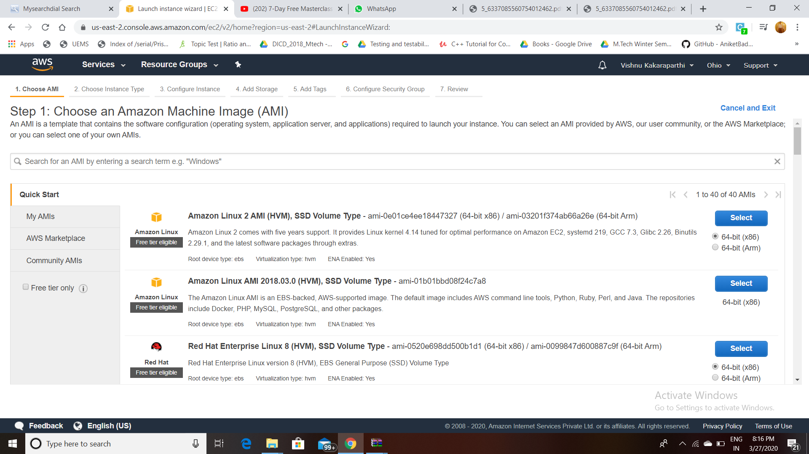

1. **CHOOSING AN INSTANCE TYPE:**

**Select t2.micro from General Purpose family.**

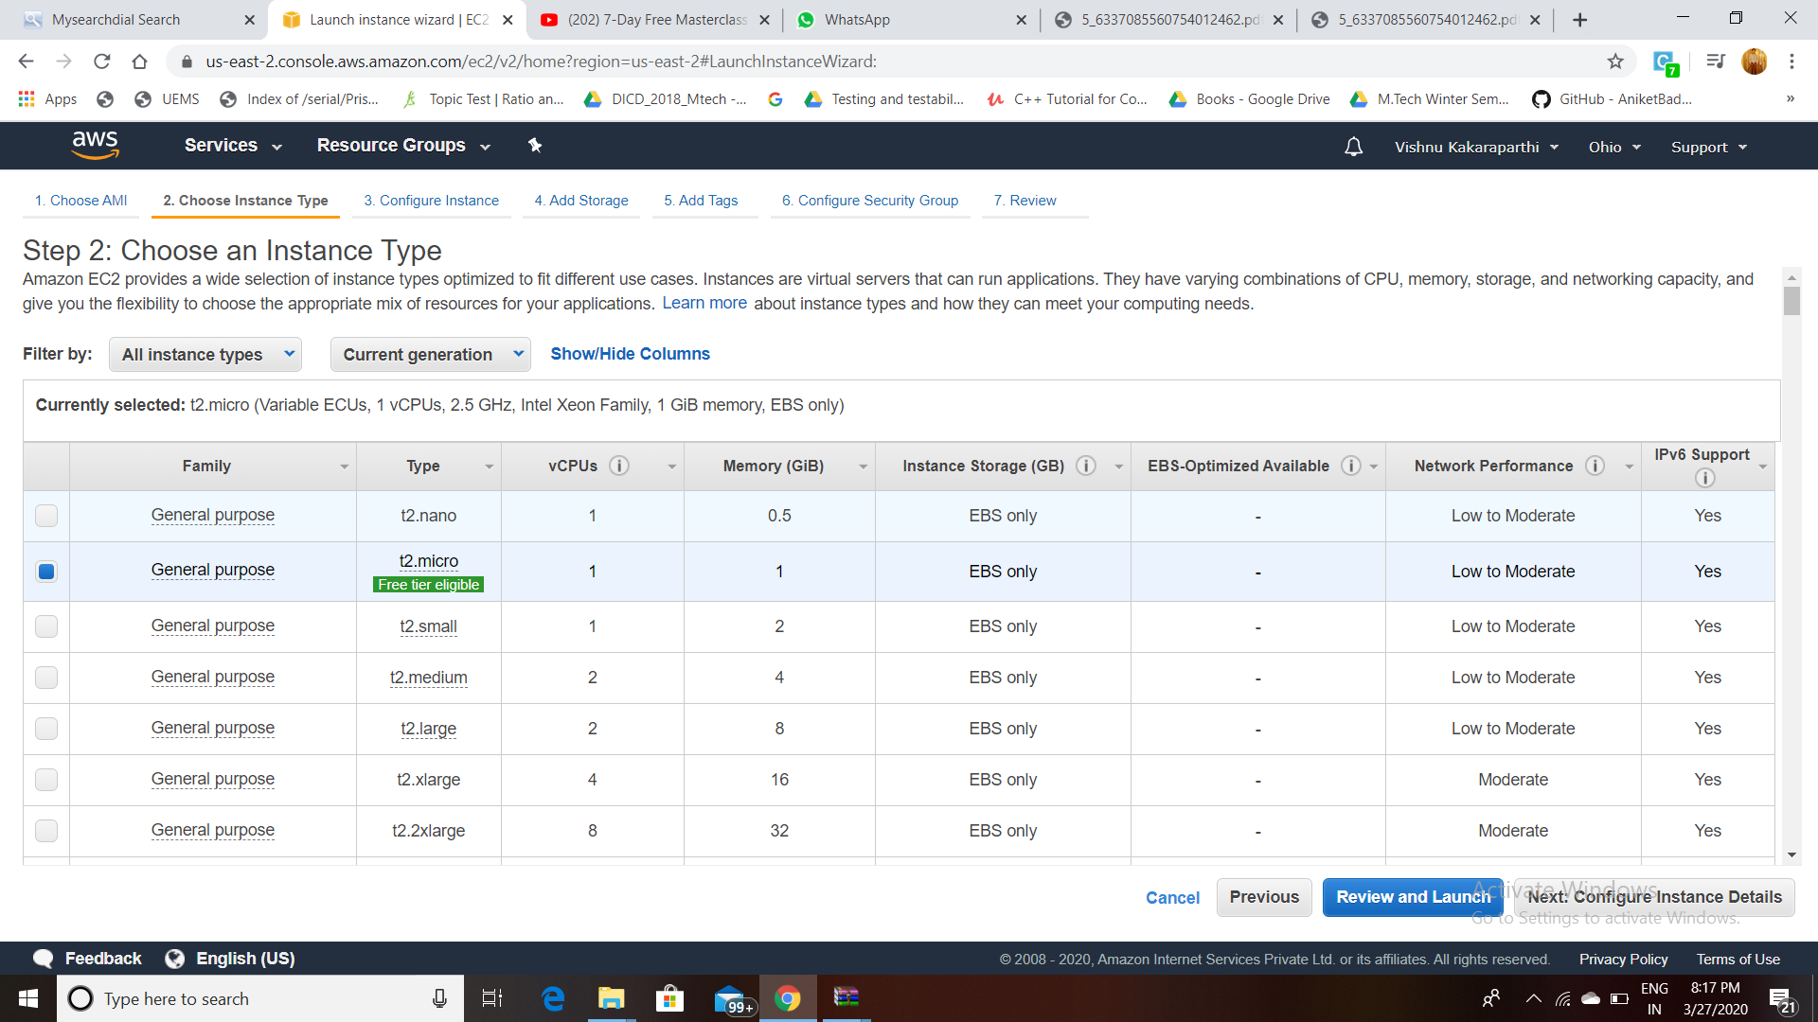

1. **ADDING STORAGE:**

**Selecting Size(GIB) as 8.**

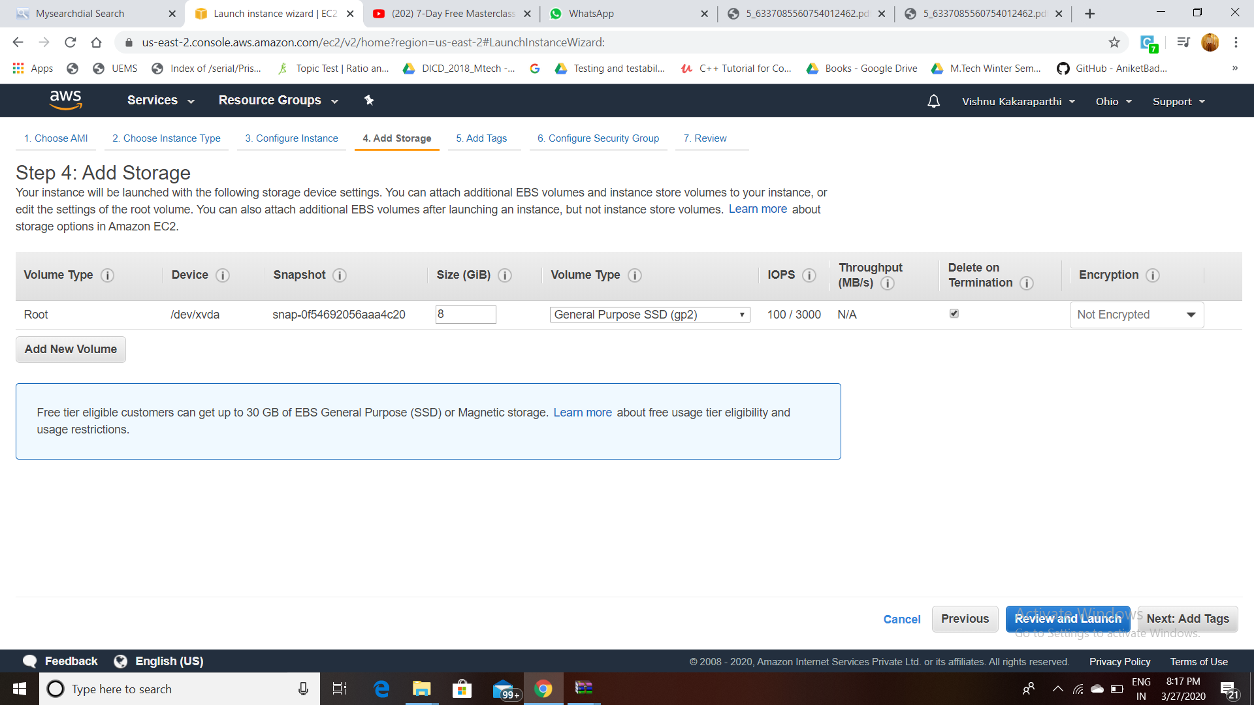

1. **CONFIGURING SECURITY GROUP:**

**Select Type as SSH and Port Range 22**

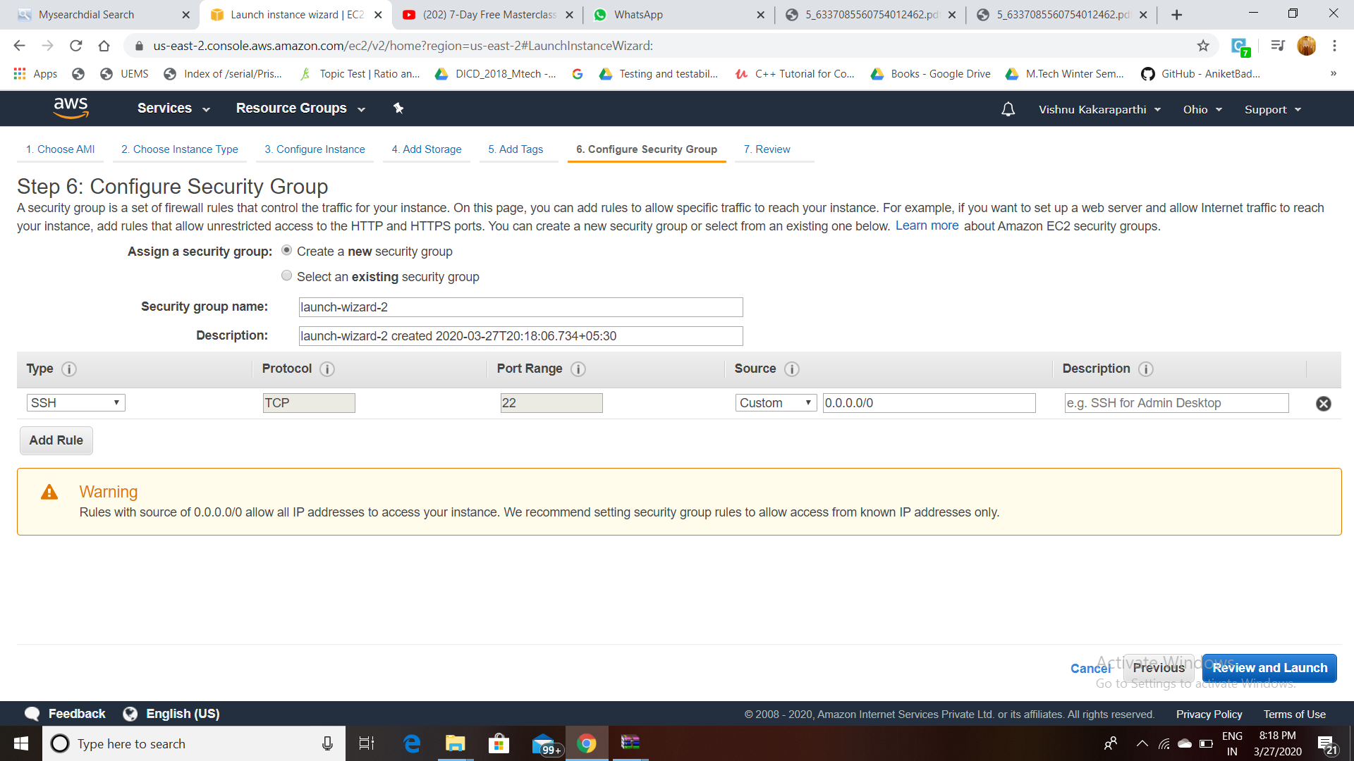

1. **KEY-PAIR DOWNLOAD:**

**After Review ,Click on Launch then popup appears where we have to create a new key pair by giving the name and download keypair which is in .pem format and then click launch Instances.**

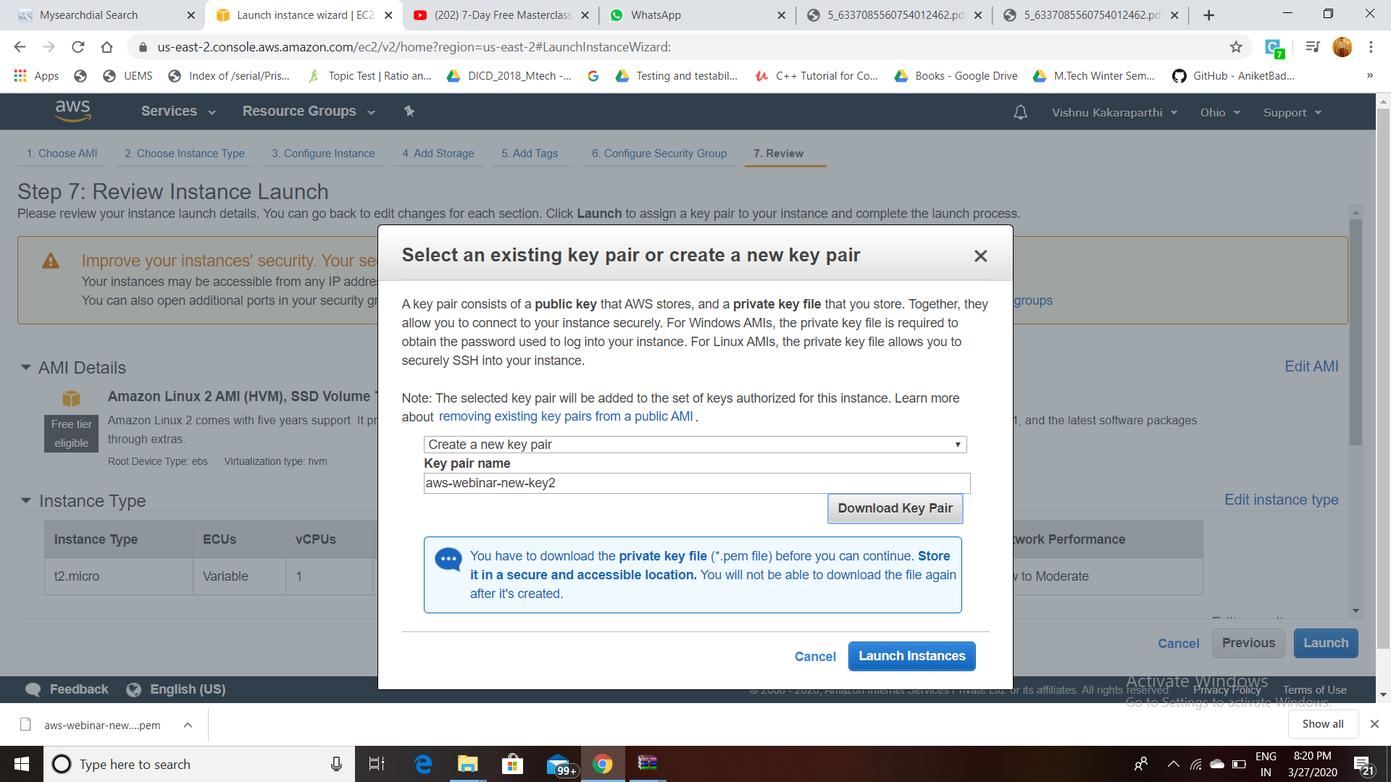

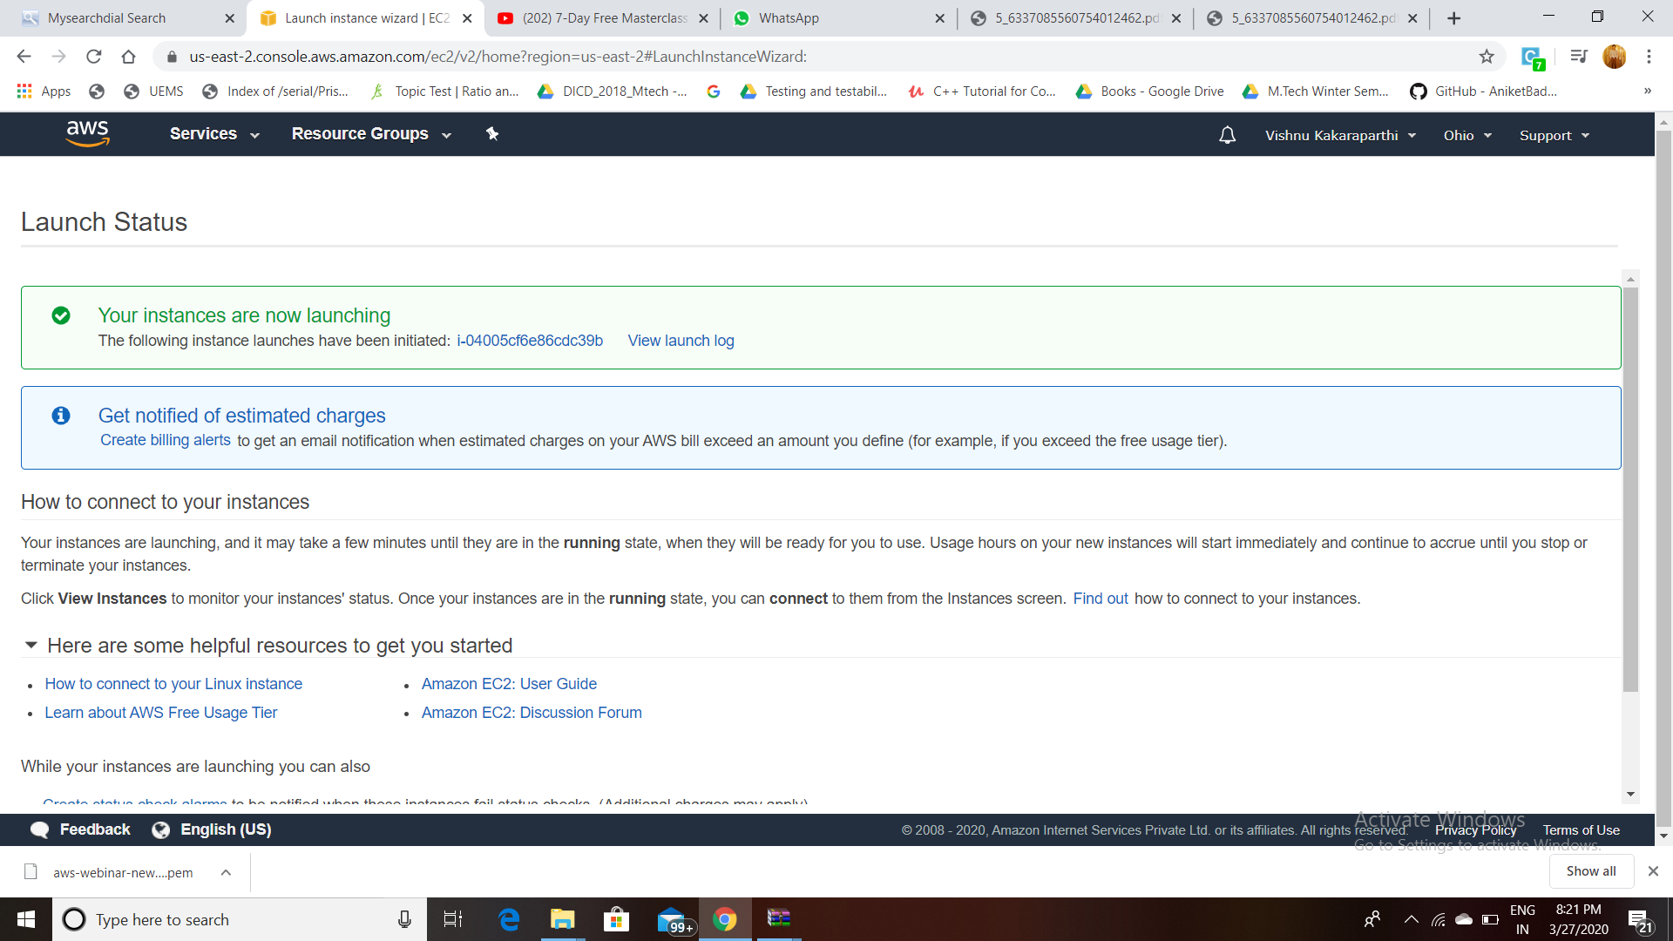

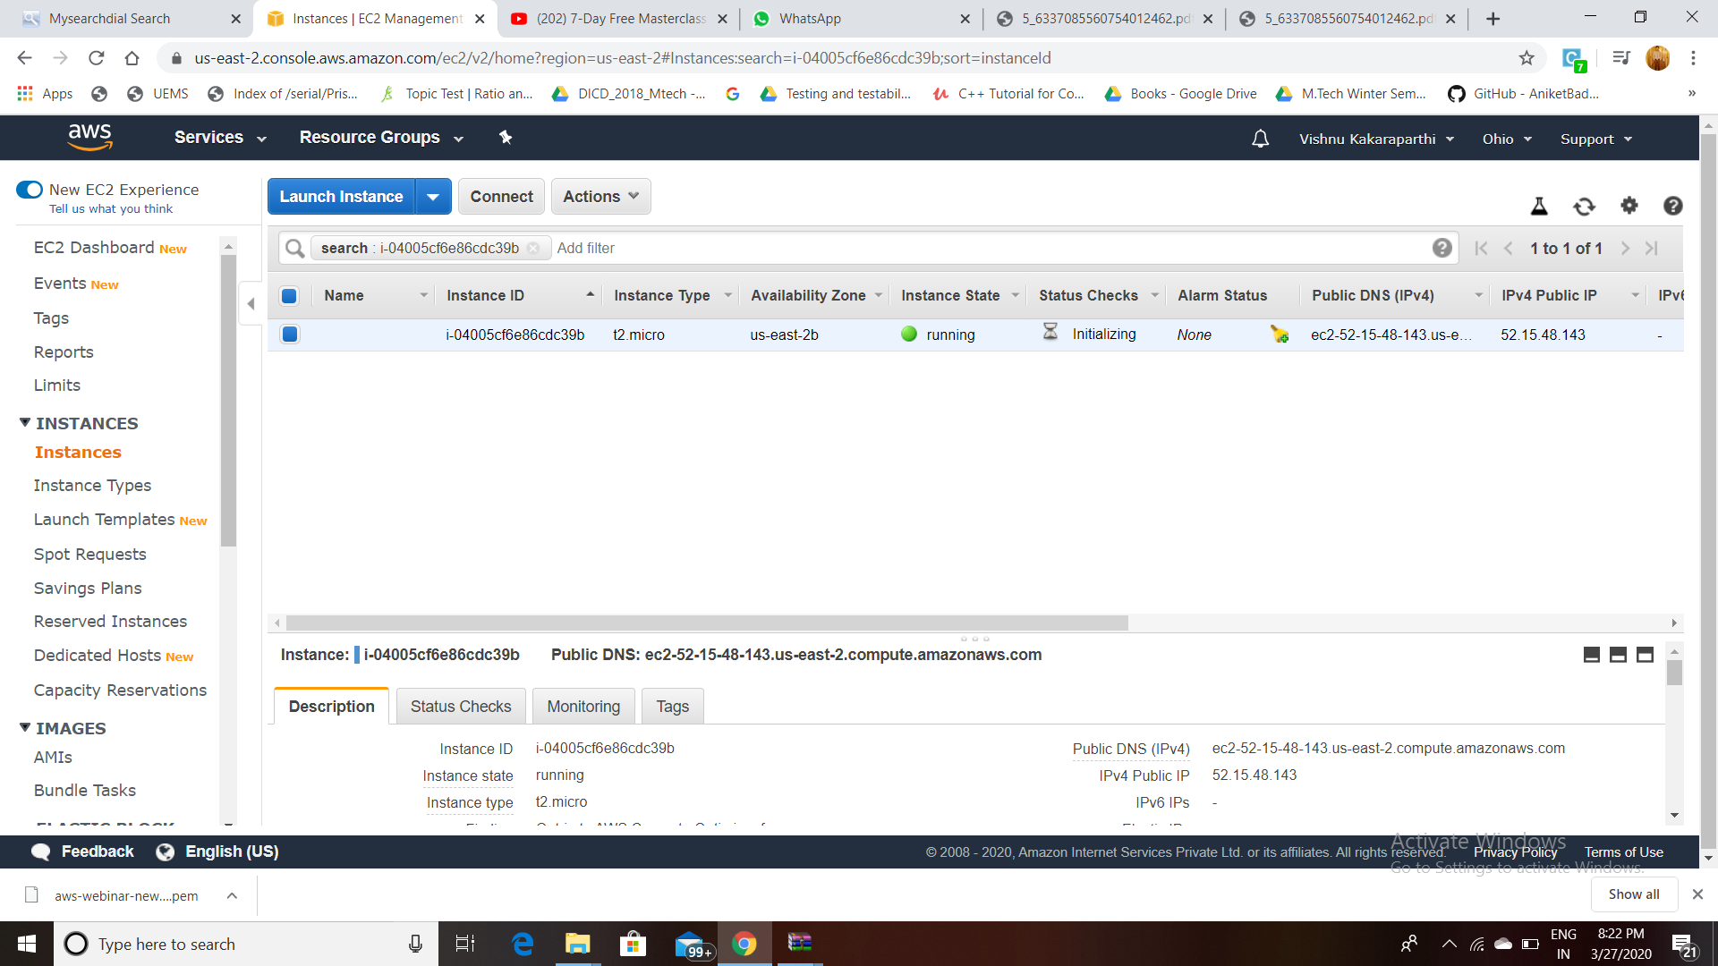

1. **PuTTYgen Conversion from pem to ppk:**

**Open PuttyGen and click on Load and select the .pem file which previously you have downloaded. One popup appears and click on Ok . and click on Save Private Key which will convert and save key file in PuTTy compatible format and popup appears click on Yes and now give the file name which will save as .ppk extension. The screenshots are below:**

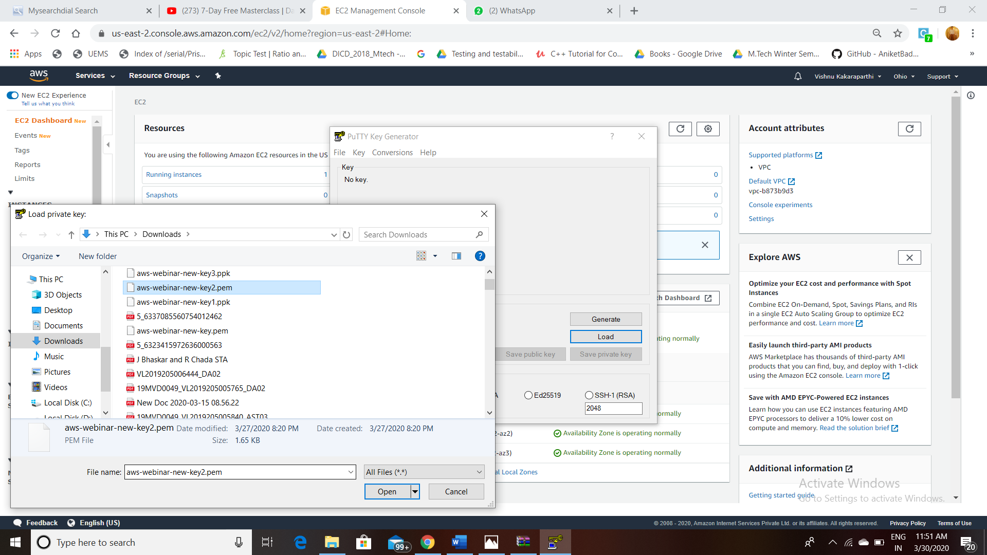

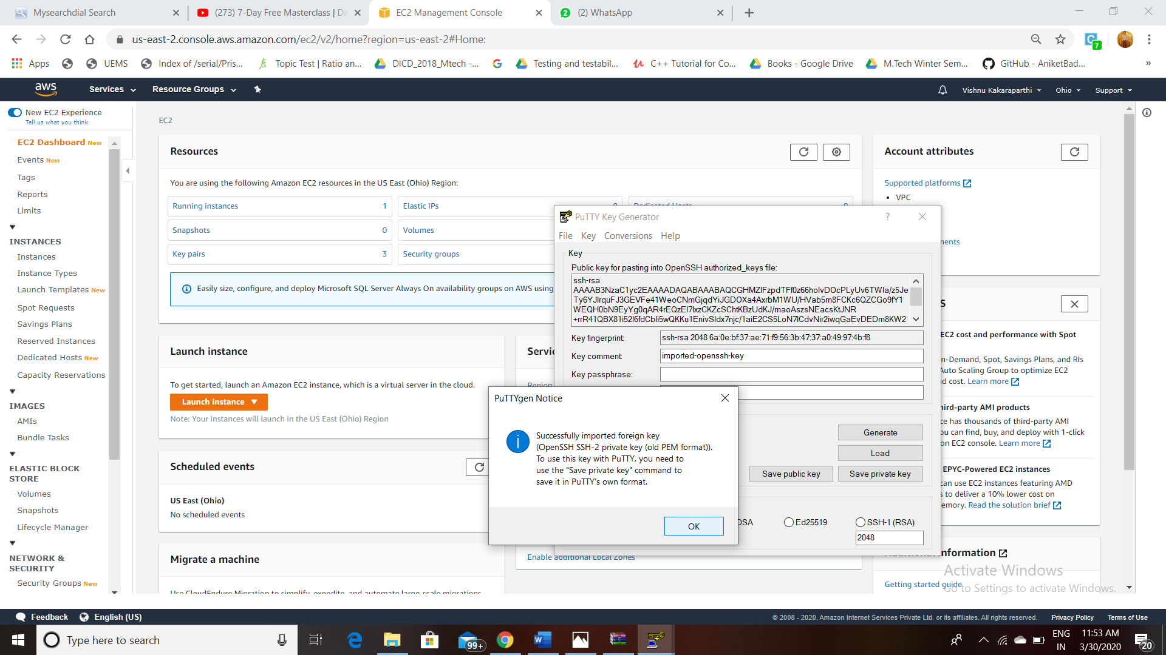

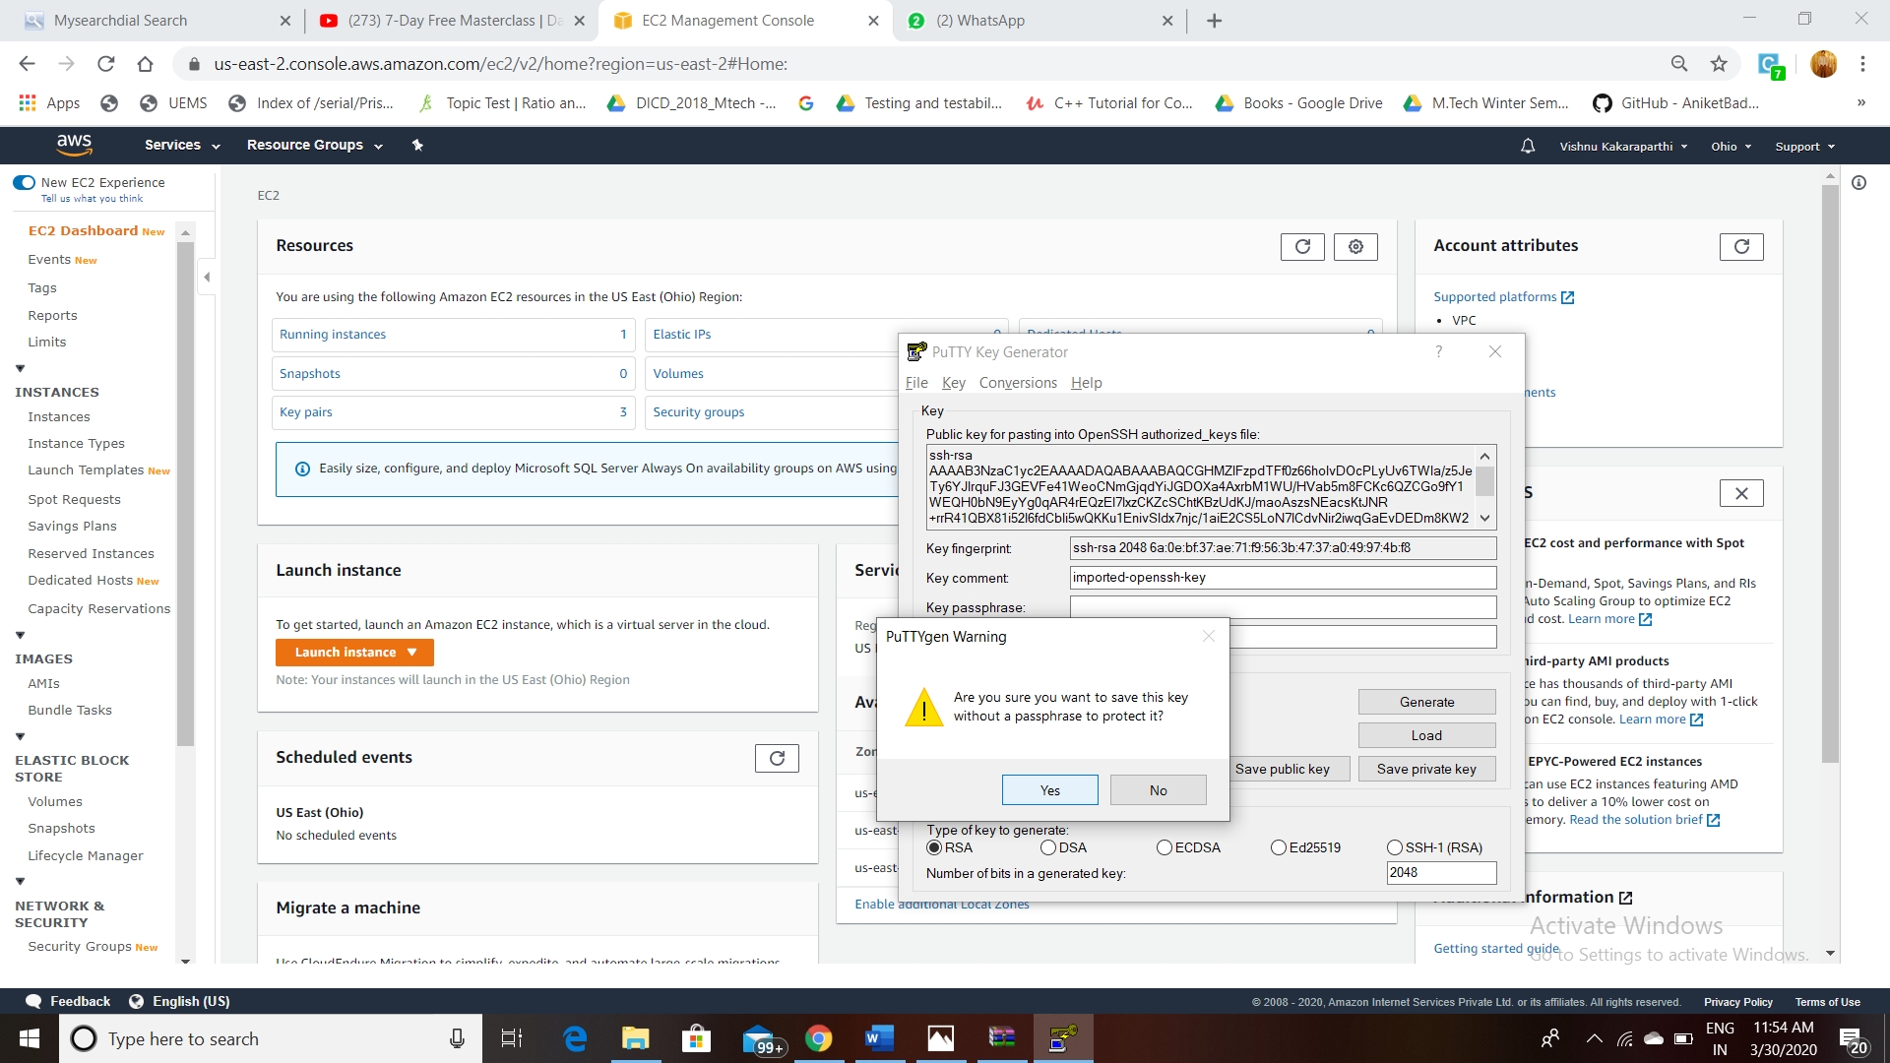

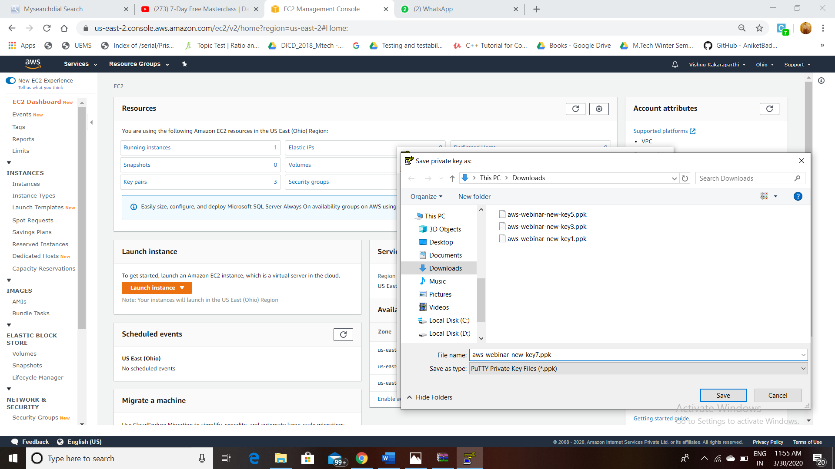

**Now, the users can connect to their EC2 instances.**

**Open puTTy on your system.**

**Ensure that port number should be same as the number which you have given in instance creation.**

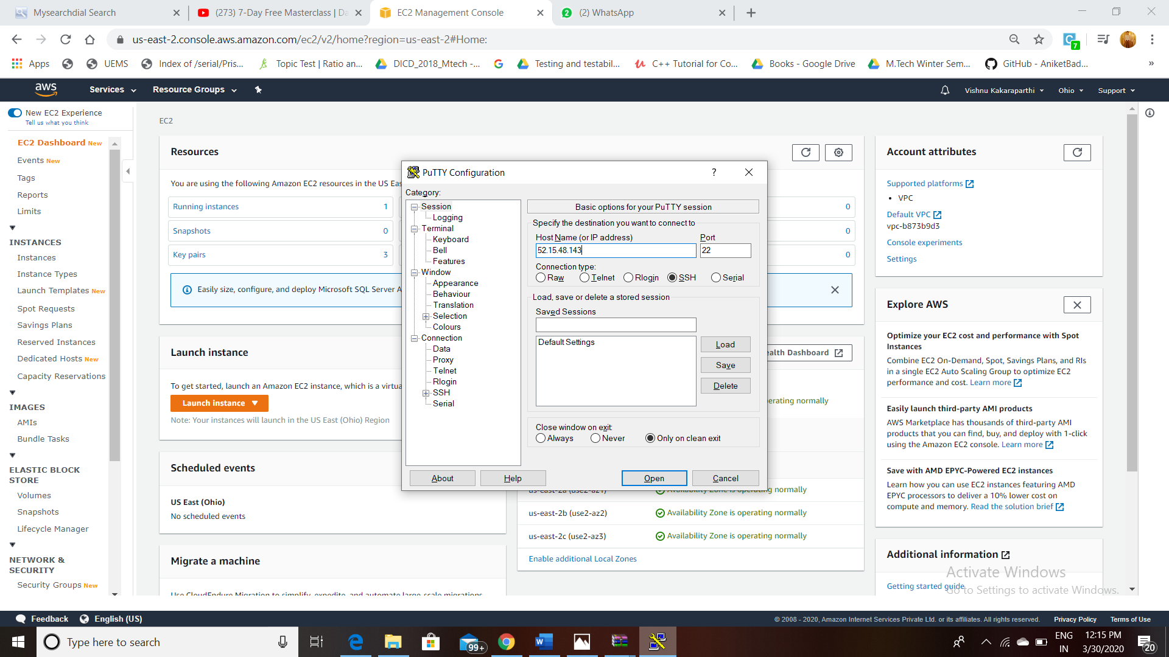

**Now ,Under Connection-> SSH-> Click on Auth-> Browse the ppk file that is converted using Putty Gen .**

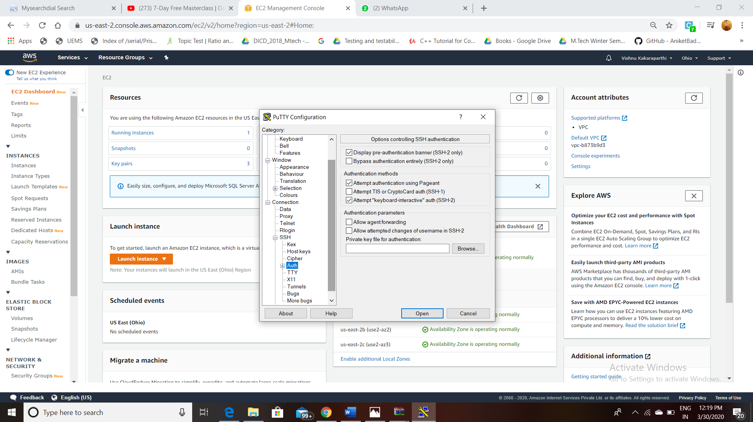

**Now, it will prompt login screen as follows:**

1. **LOGGED In EC2 BLACKSCREEN:**

**Enter ec2-user and hit enter and you will connect to EC2**

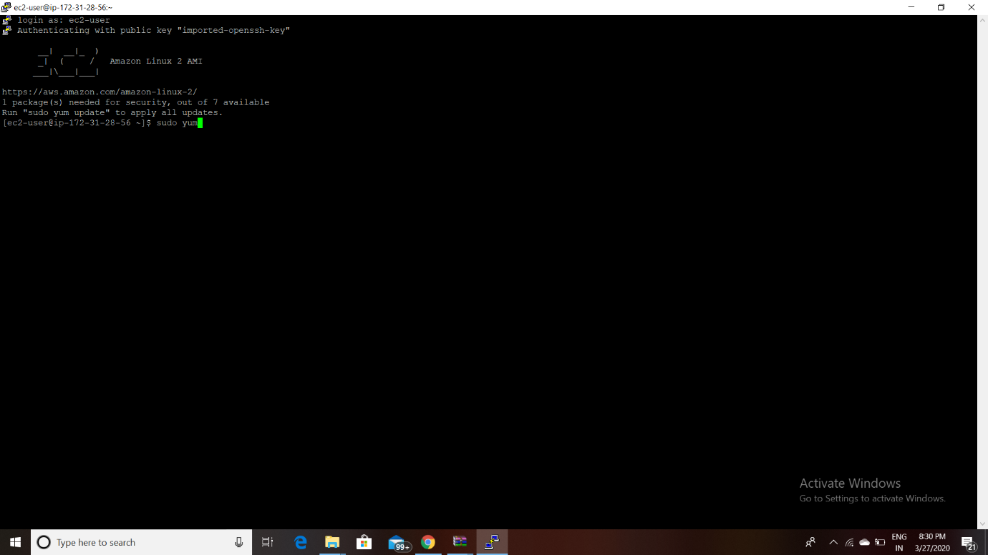

1. **DAY-1 TASK (Create your own server ) SCREENSHOTS:**

**STEP1: Installing a server by following commands**

* **sudo yum install httpd**
* **sudo service httpd start**
* **sudo service httpd status**
* **sudo vim/var/www/html/index.html**

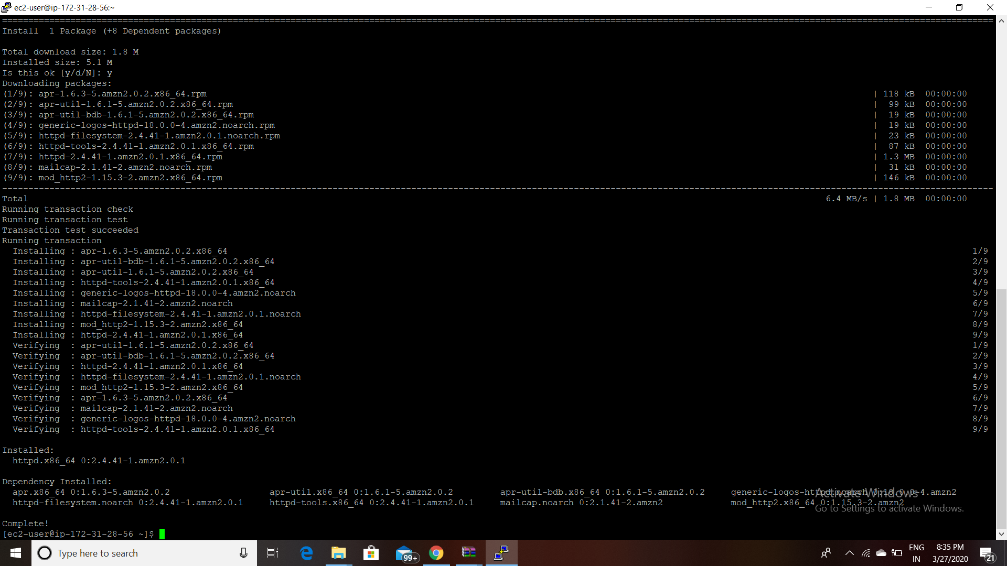

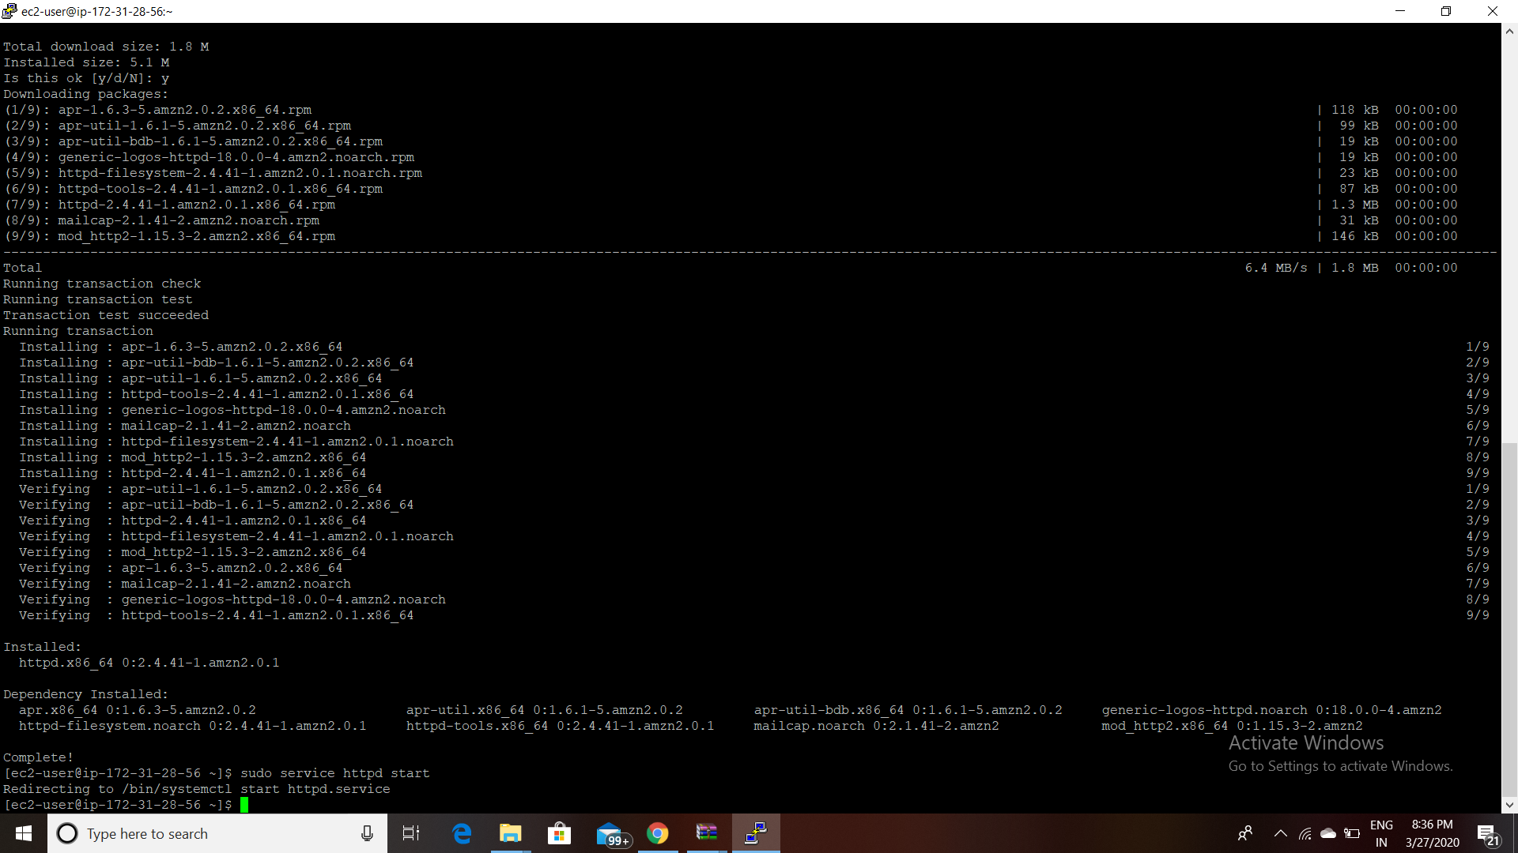

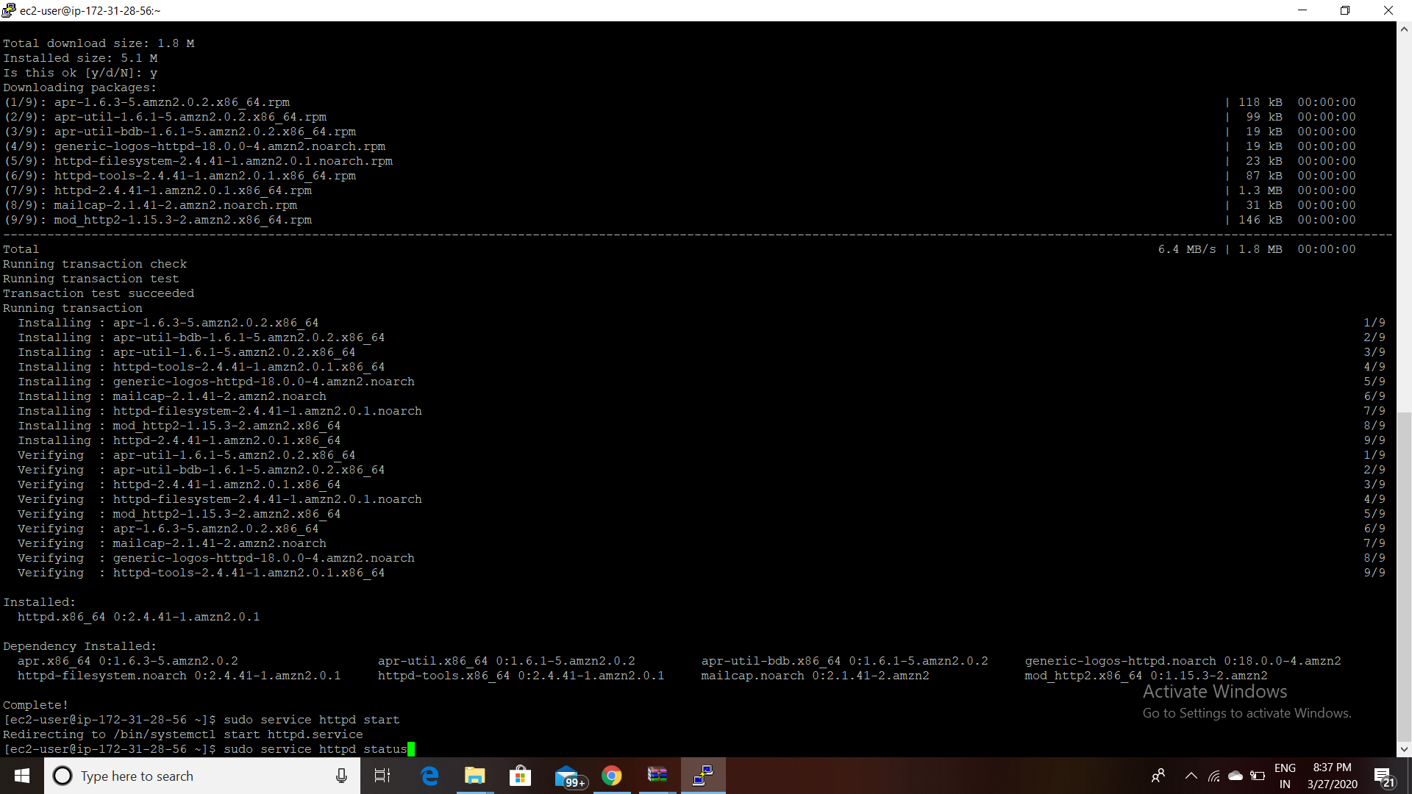

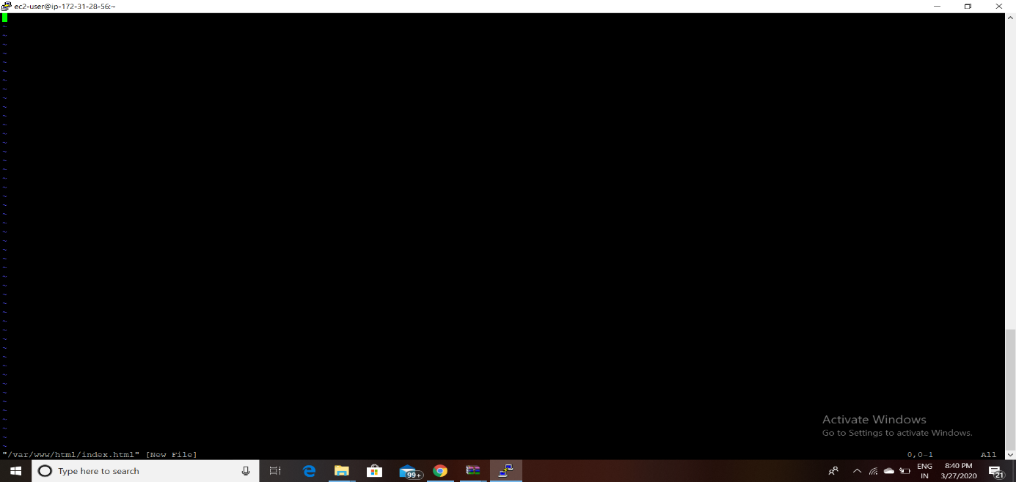

**After this screen appears ,type I which changes to INSERT ,Now type anything which you want to visible on server.and type esc:wq and hit enter which saves the file.**

**Now go to instance in the AWS and select the instance you have created and go to launch-wizard-2 and in that edit inbound rules and select type ‘HTTP’ and port Range as ‘80’ and source as ‘Anywhere’.and now run the IP which you will get info what you have written in the file.**

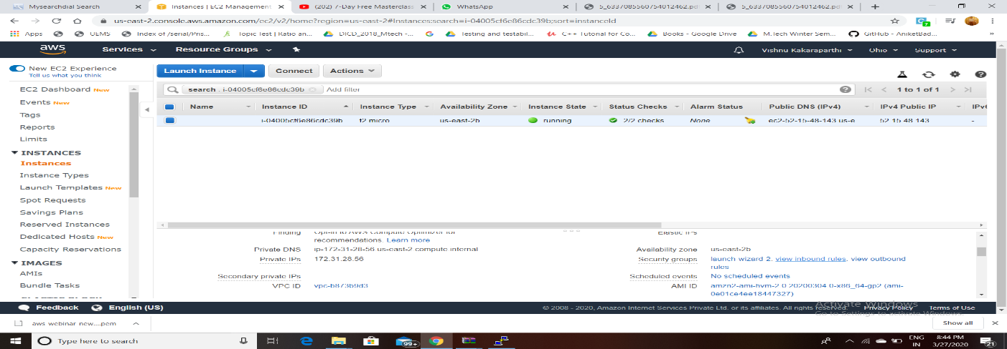

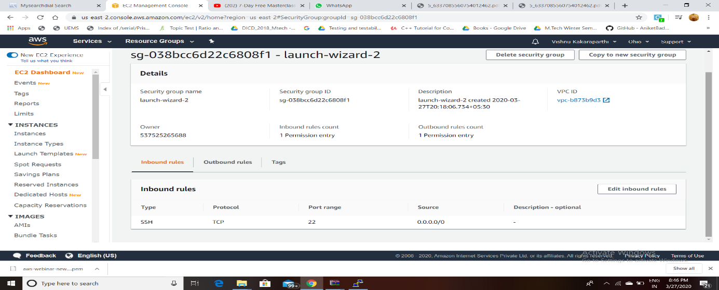

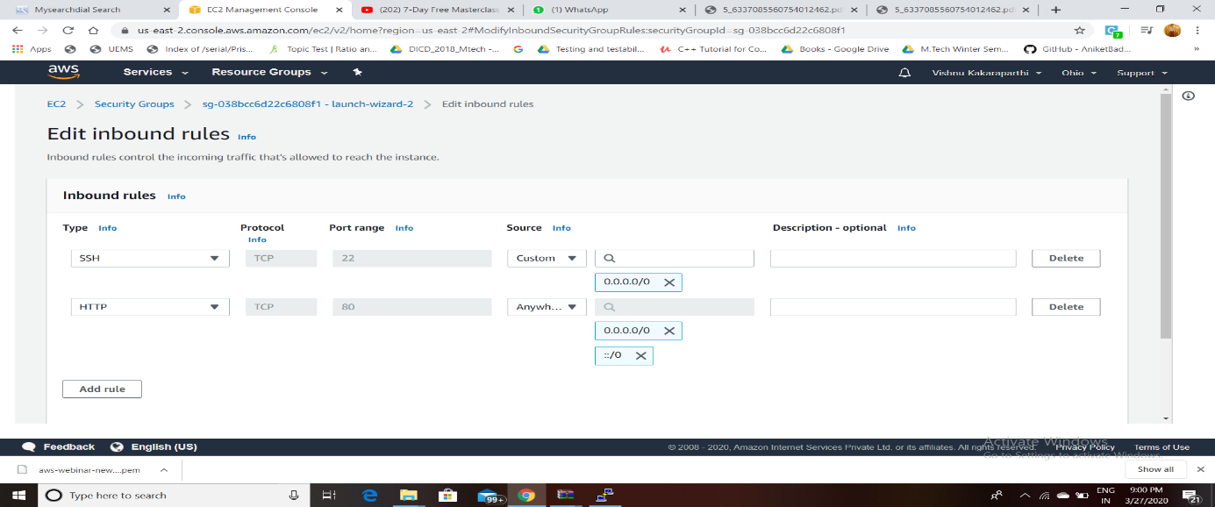

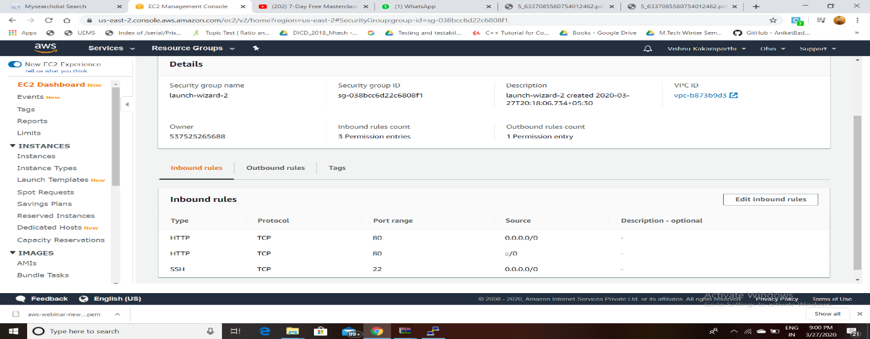

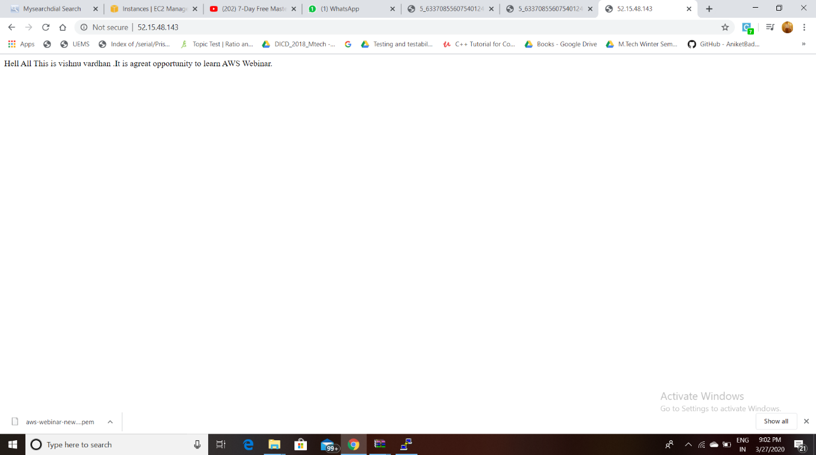

**RESULT : DAY 1 TASK(CREATION OF OWN SERVER) COMPLETED SUCCESSFULLY.**

**PART3 (S3) SCREENSHOTS:**

1. **CREATION OF BUCKET:**

**Go to S3 -> Click on Create bucket.**

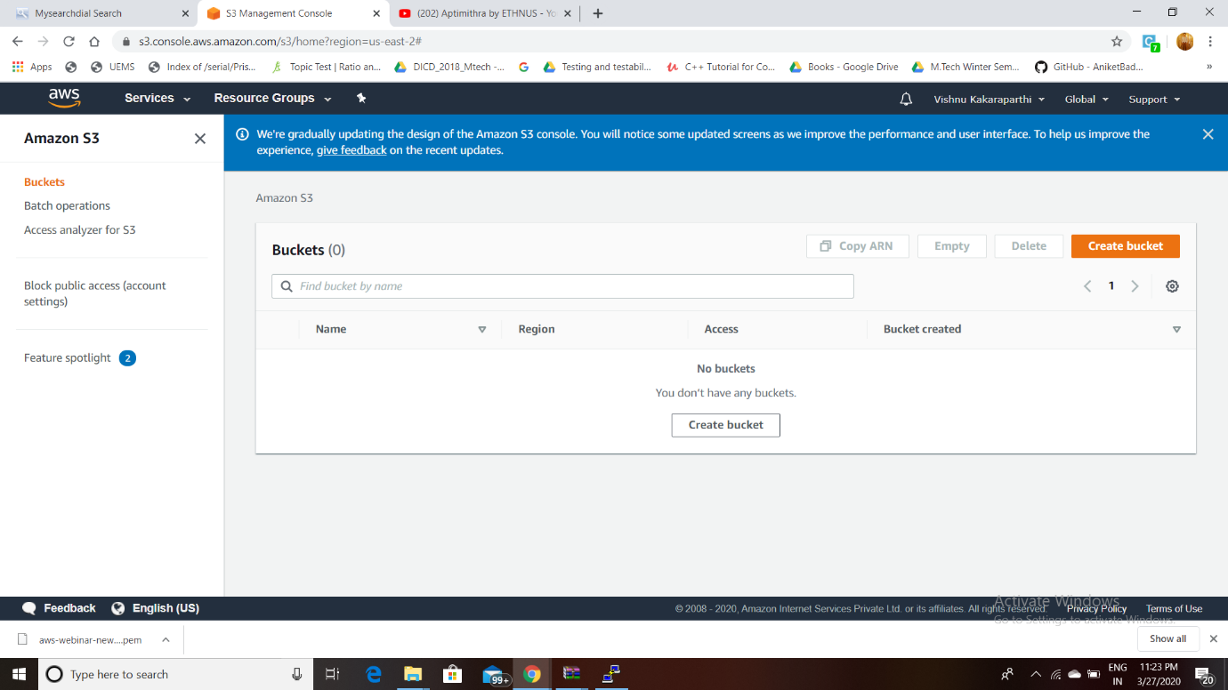

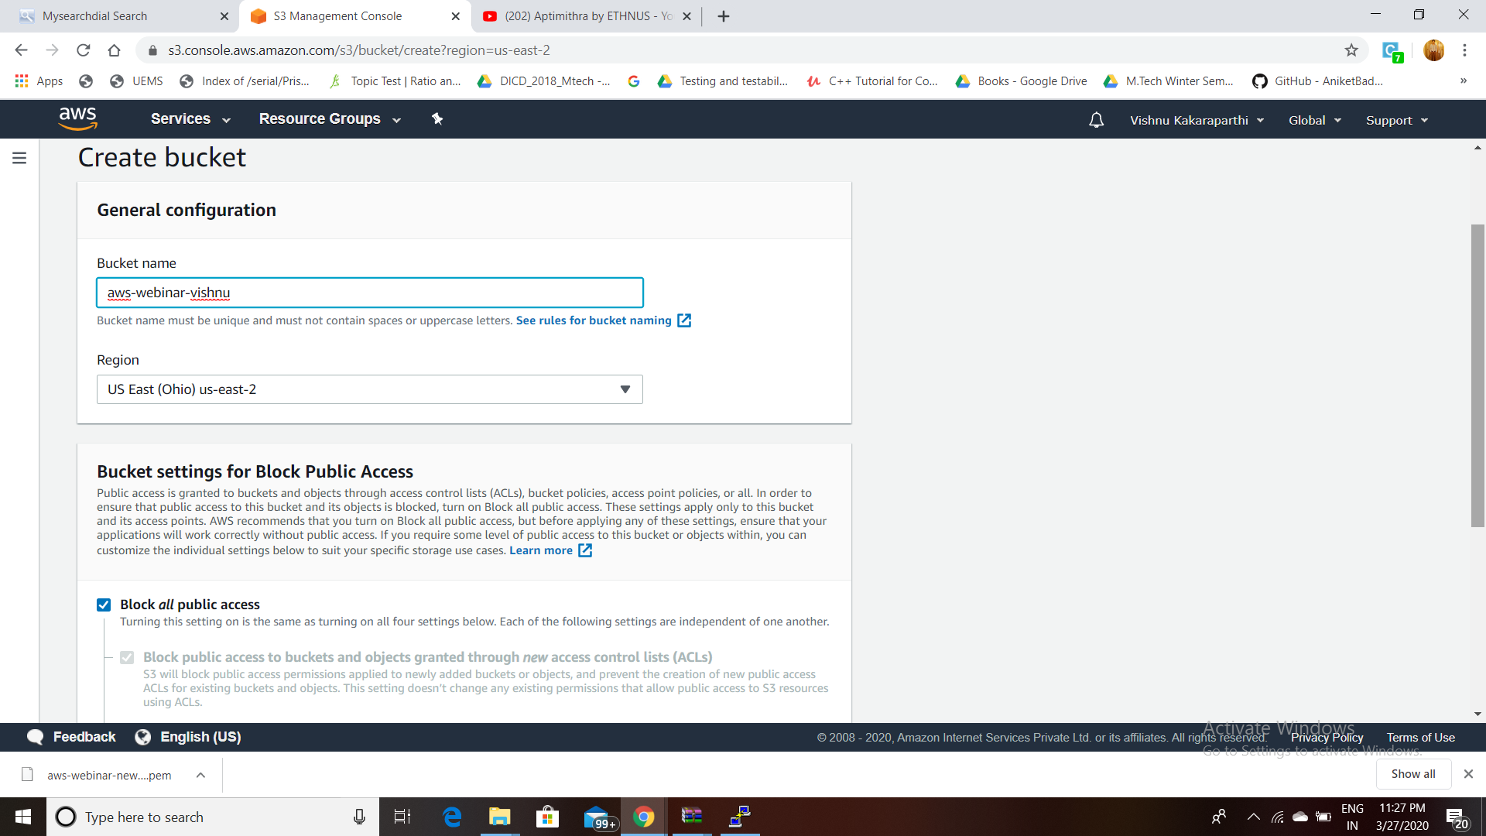

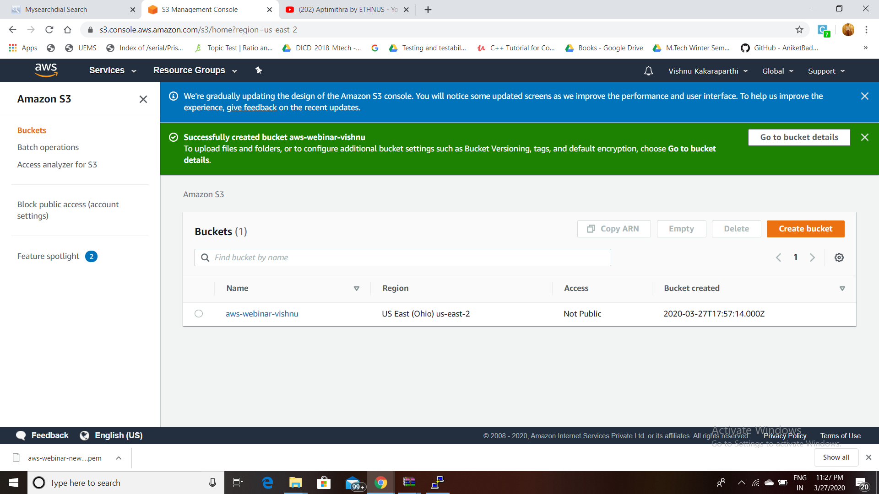

1. **UPLOADING AN OBJECT:**

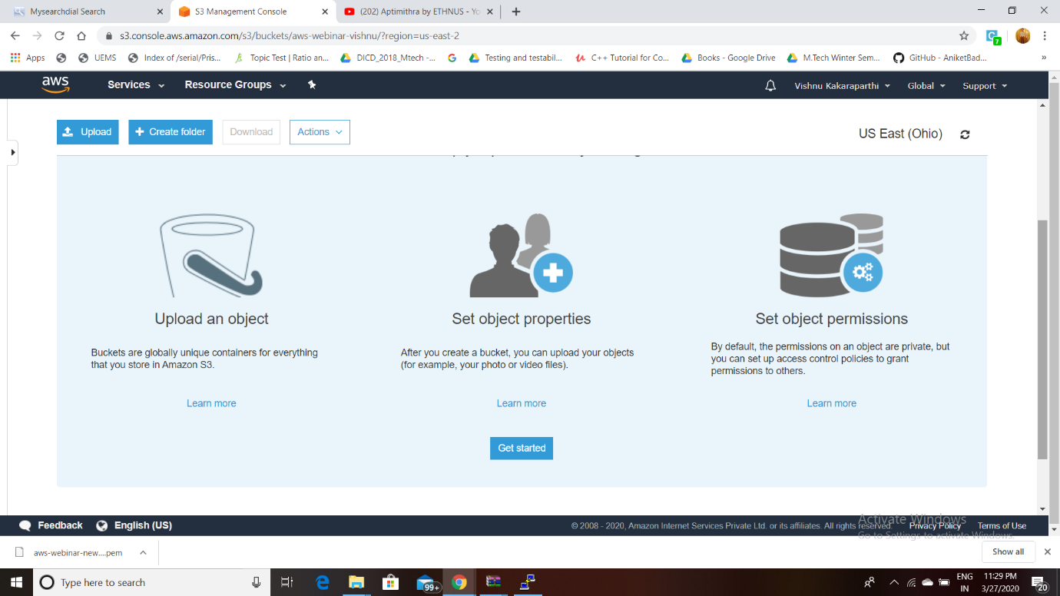

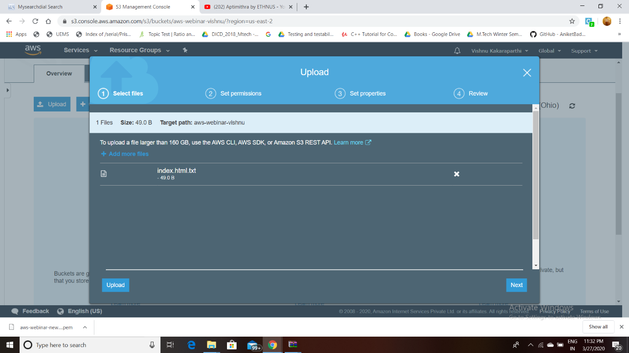

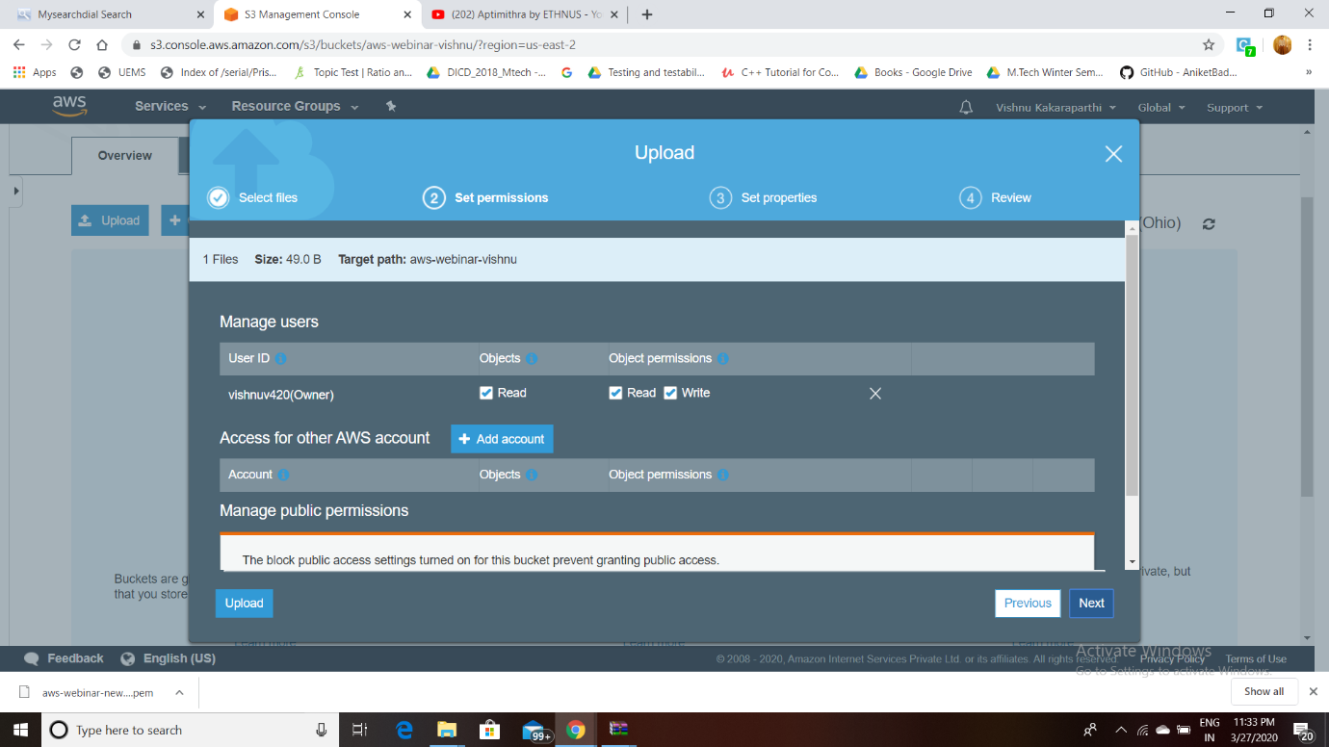

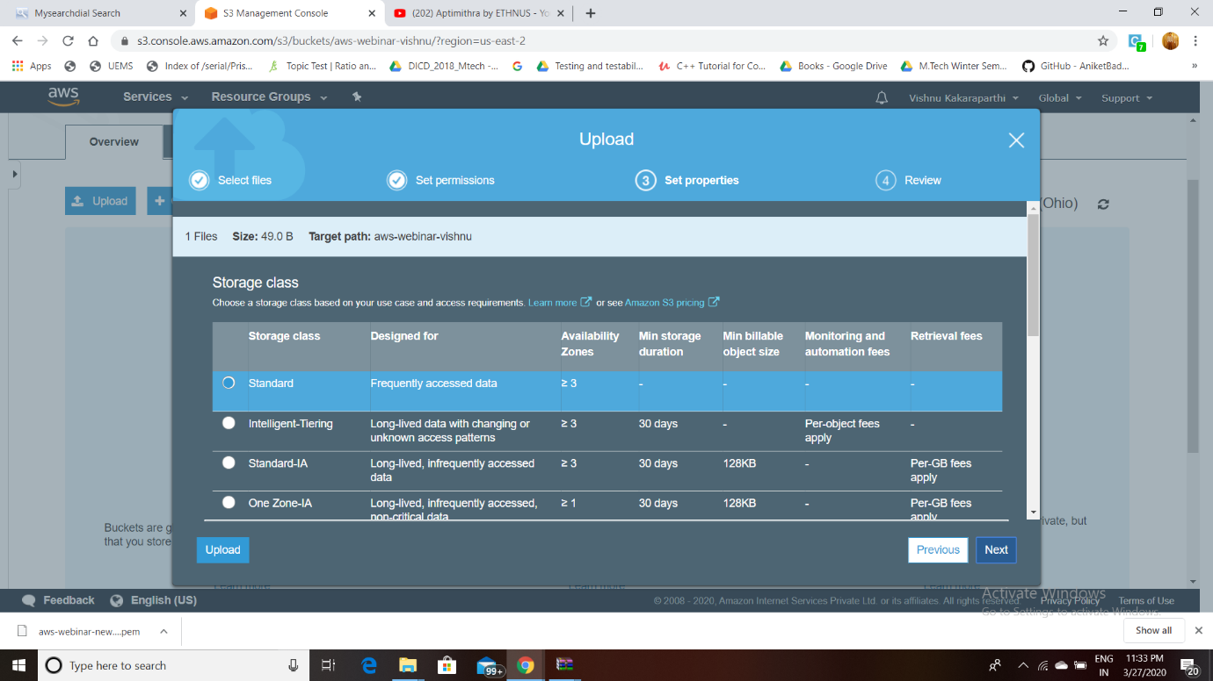

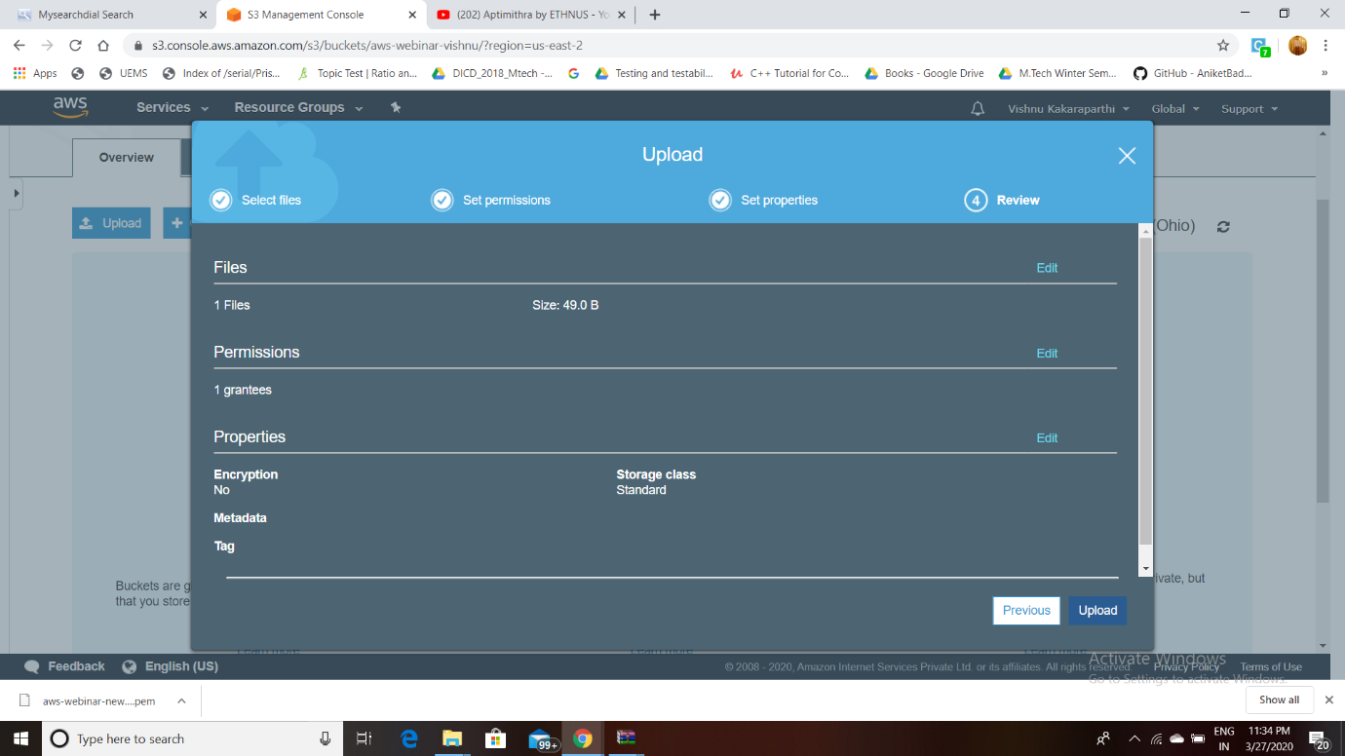

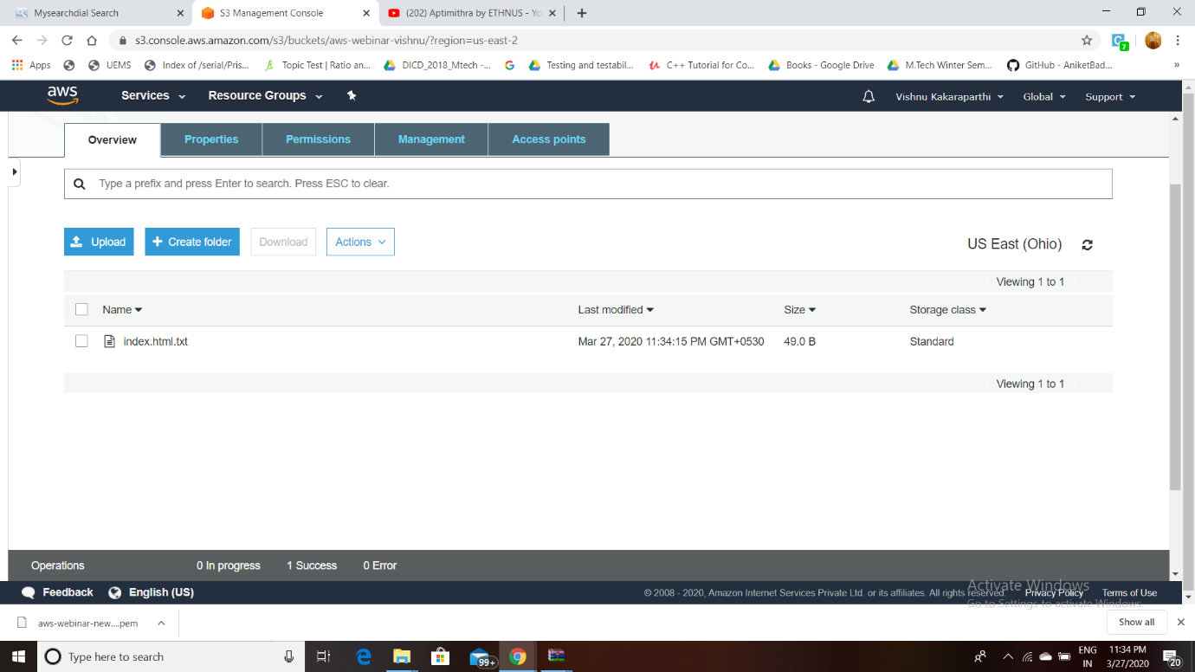

1. **ENABLING STATIC WEBSITE:**

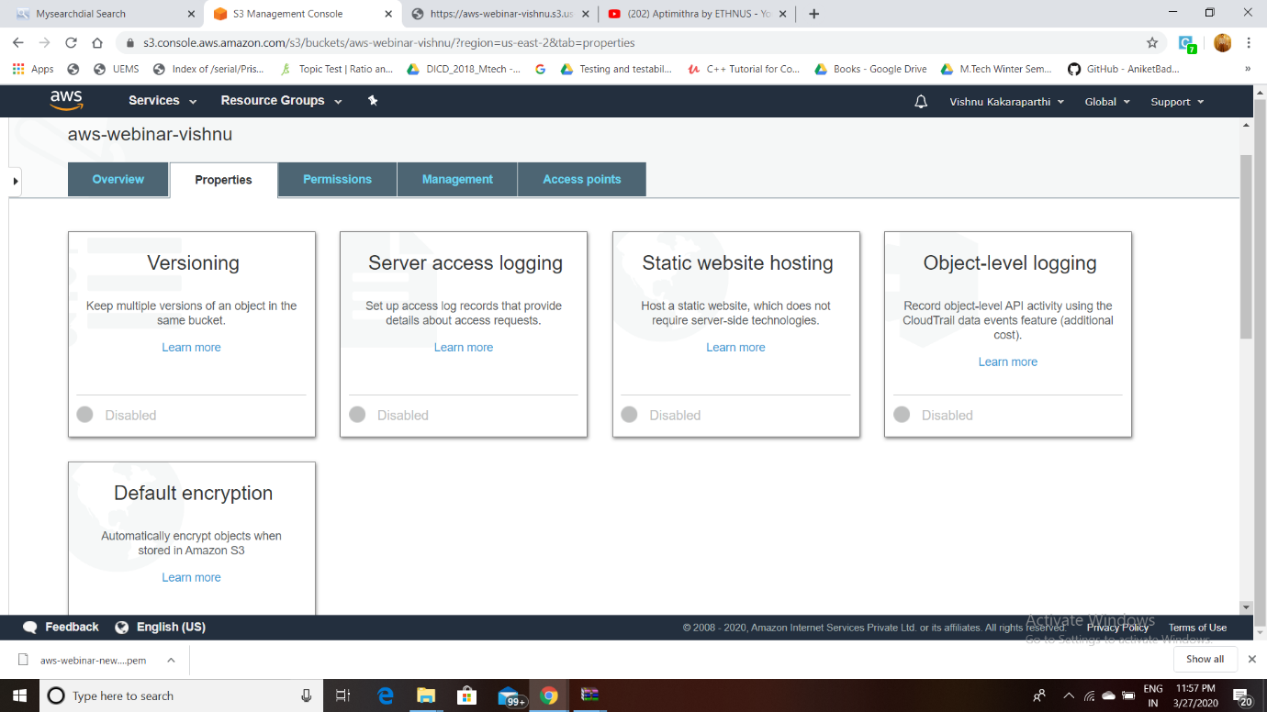

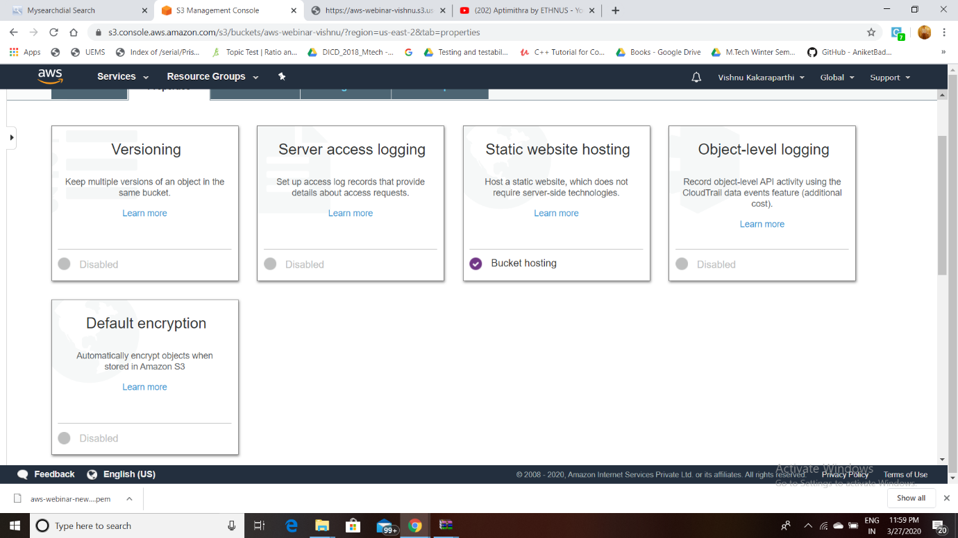

1. **Making The Object Public:**

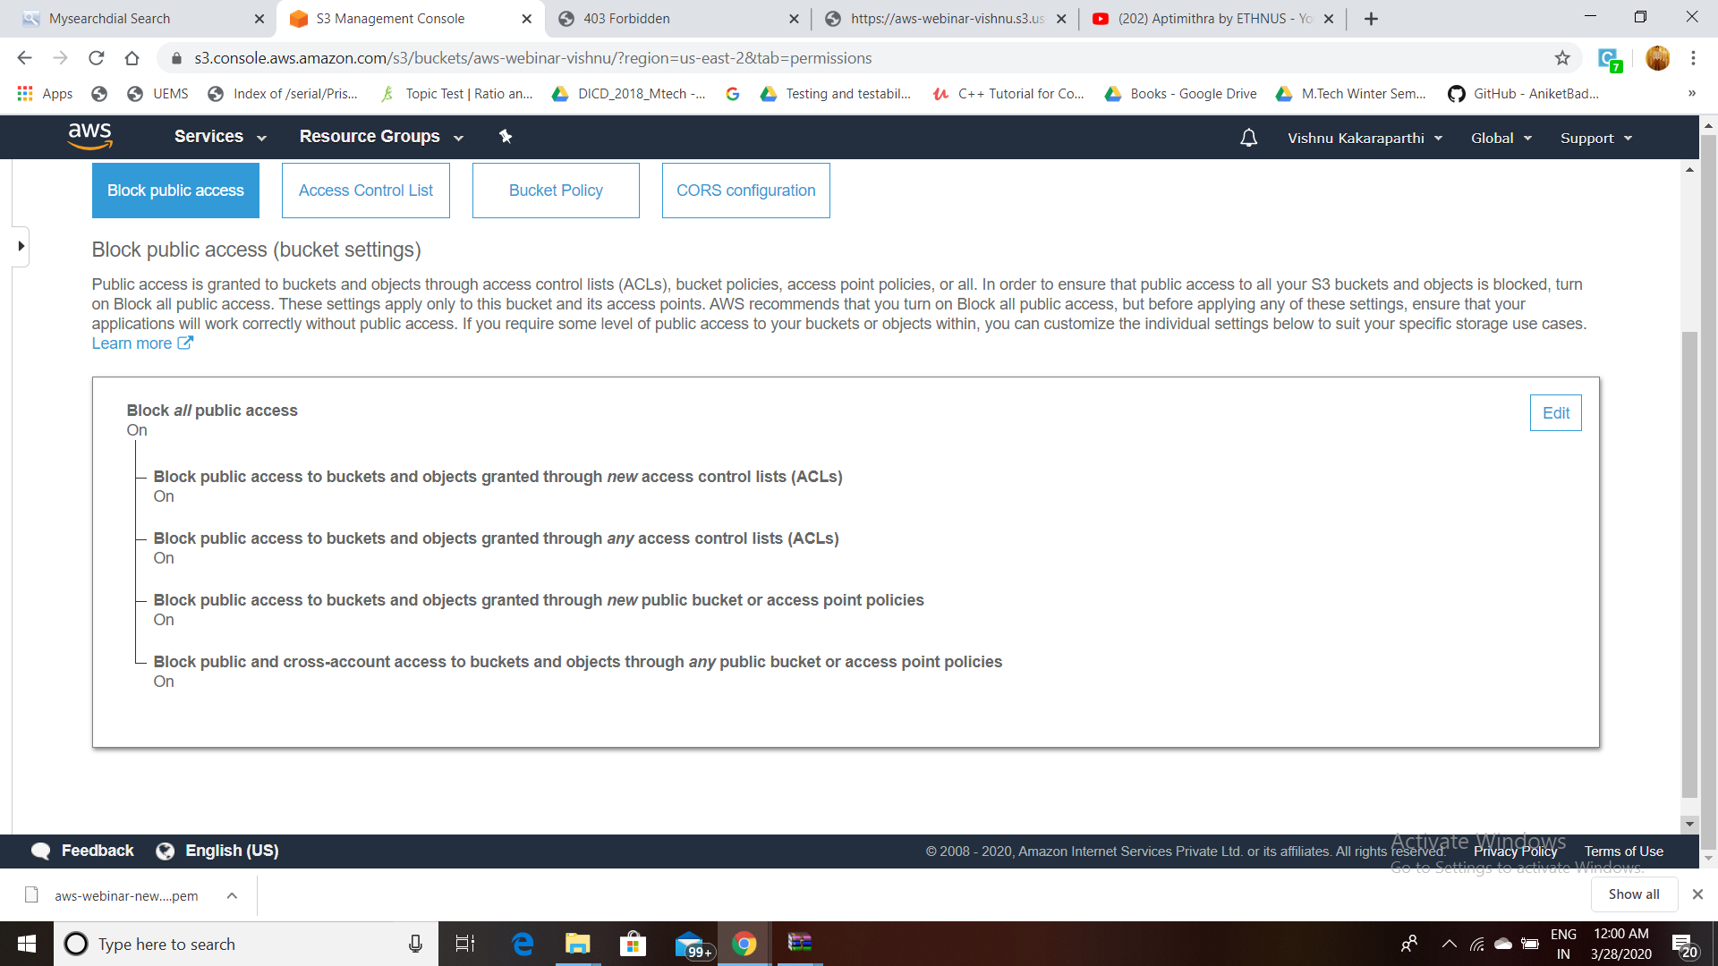

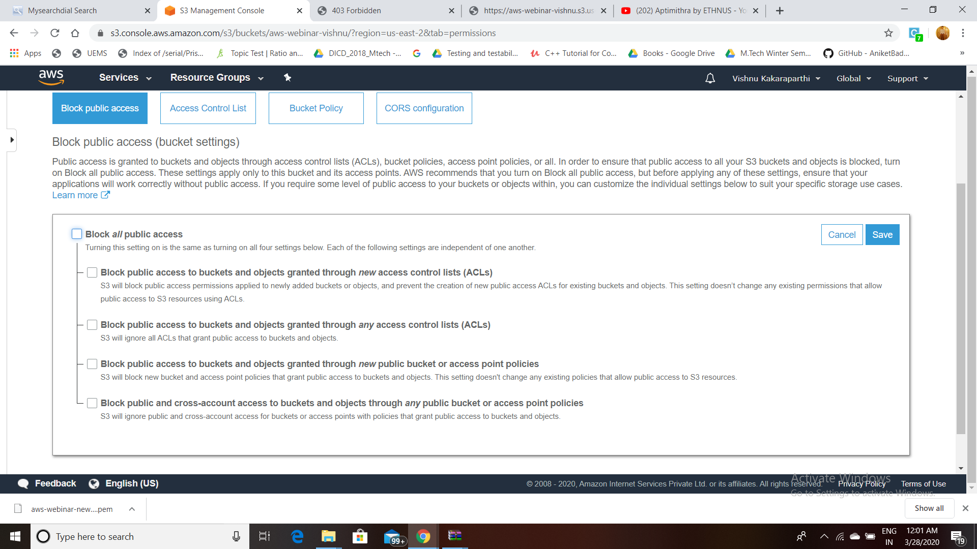

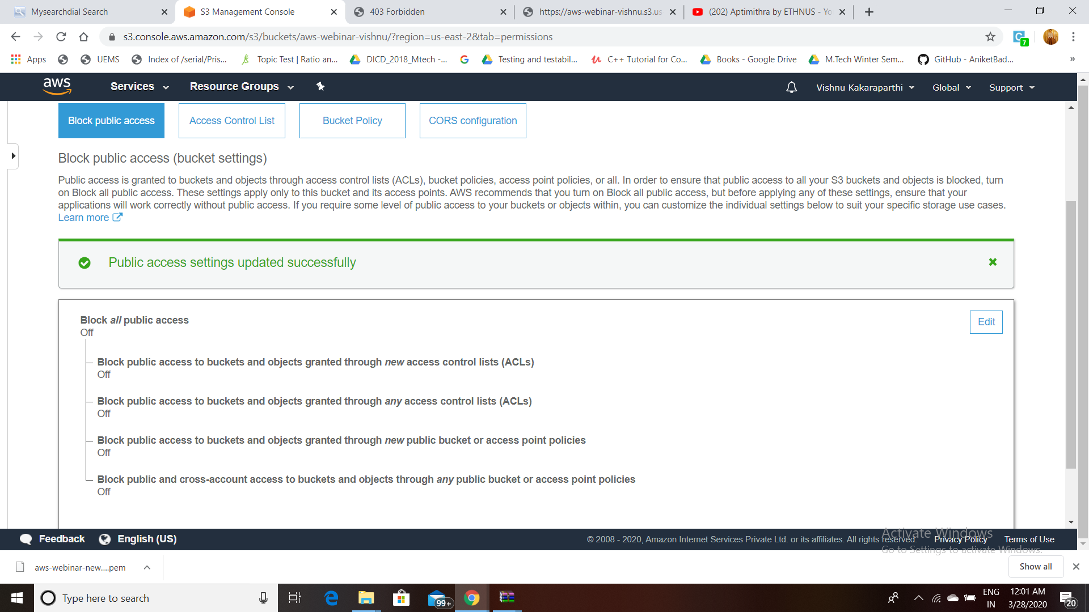

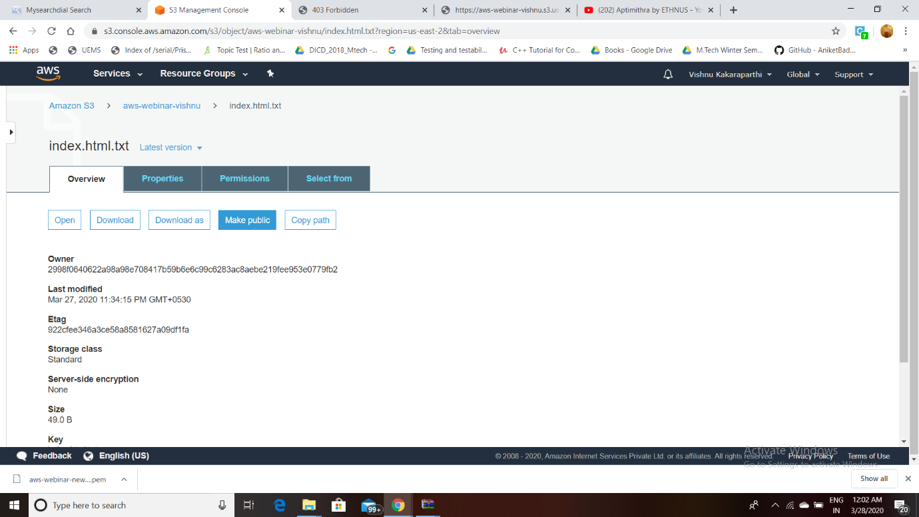

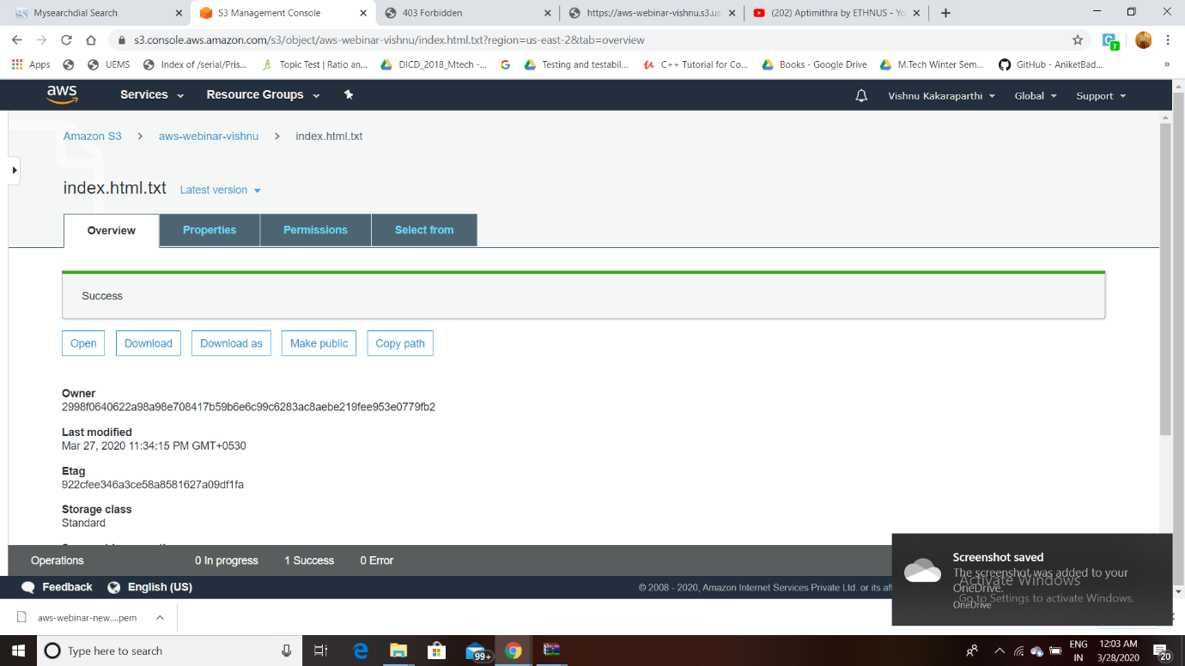

1. **CHECKING S3 Link On Browser:**

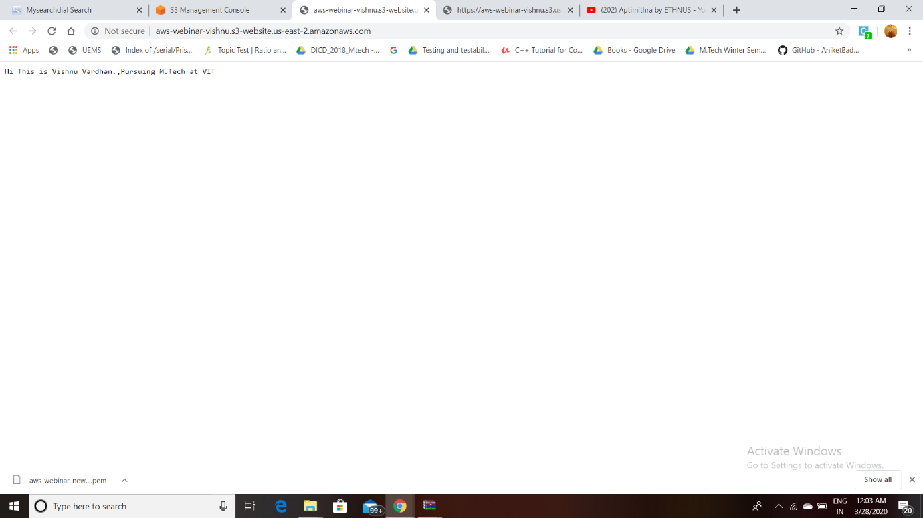

**RESULT : Hosting a Static website is completed successfully.**

**PART4 SCREENSHOTS (REKOGNITION):**

1. **FACE DETECT:**

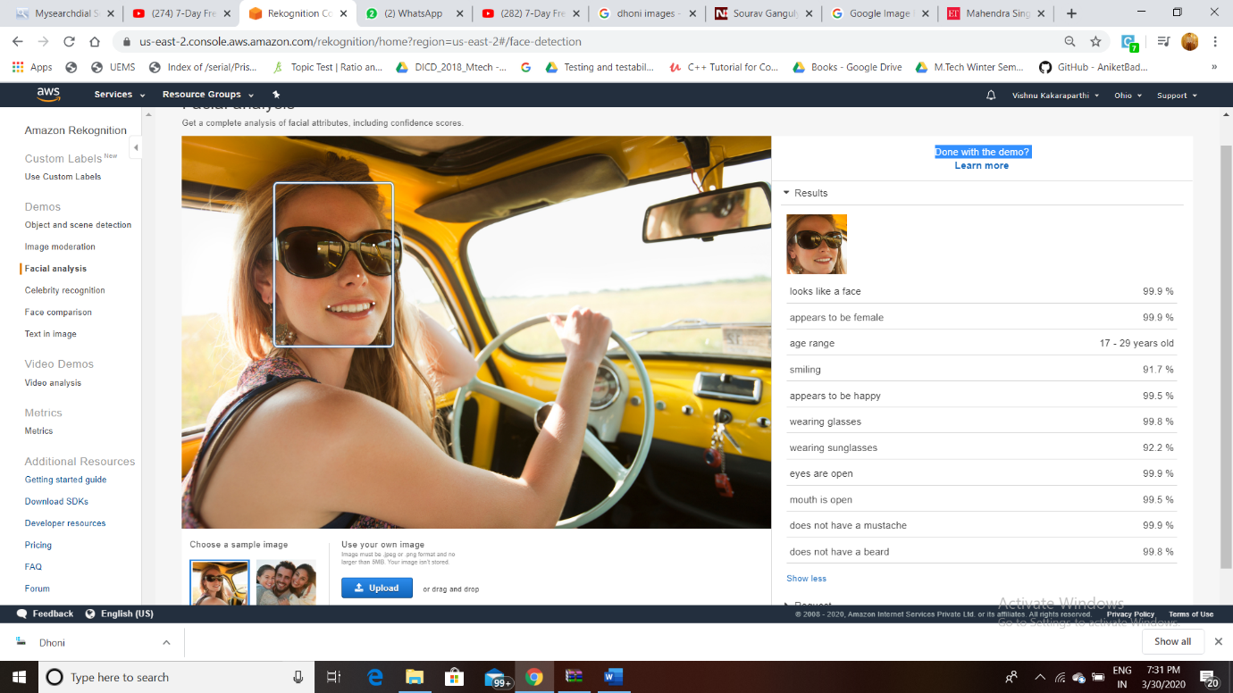

1. **FACE COMPARE:**

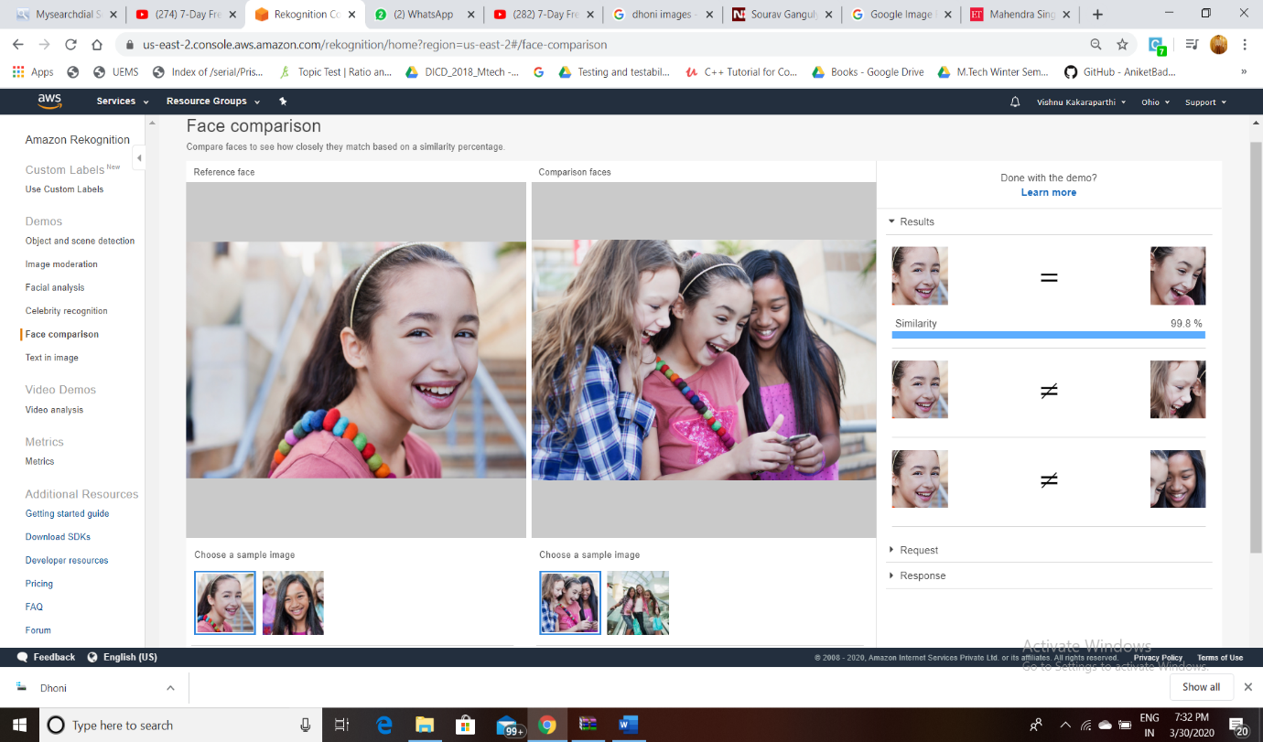

1. **CELEBRITY RECOGNITION:**

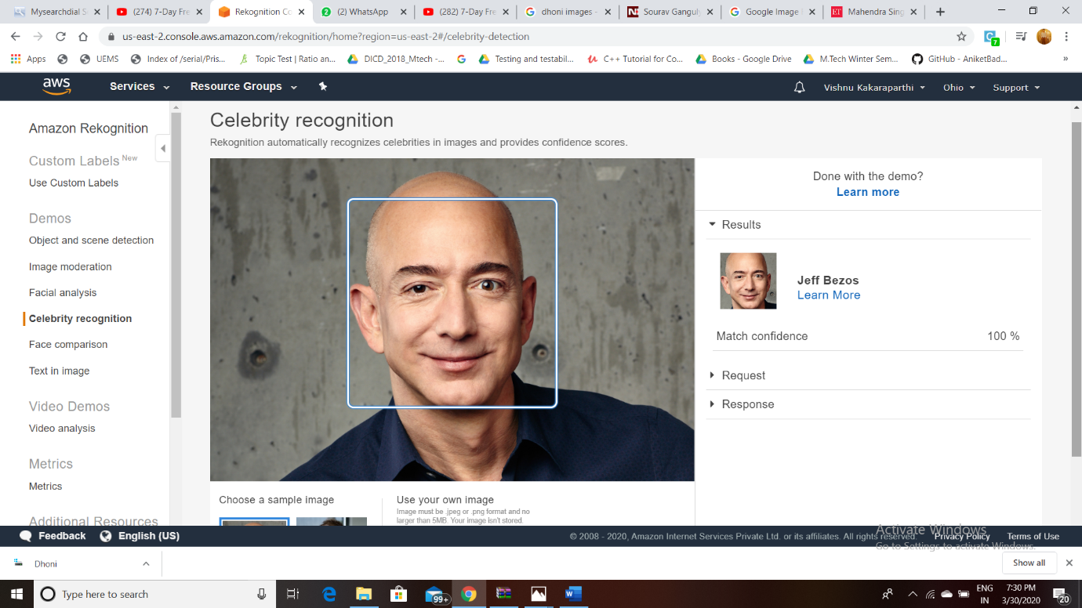

1. **TEXT IN IMAGE:**

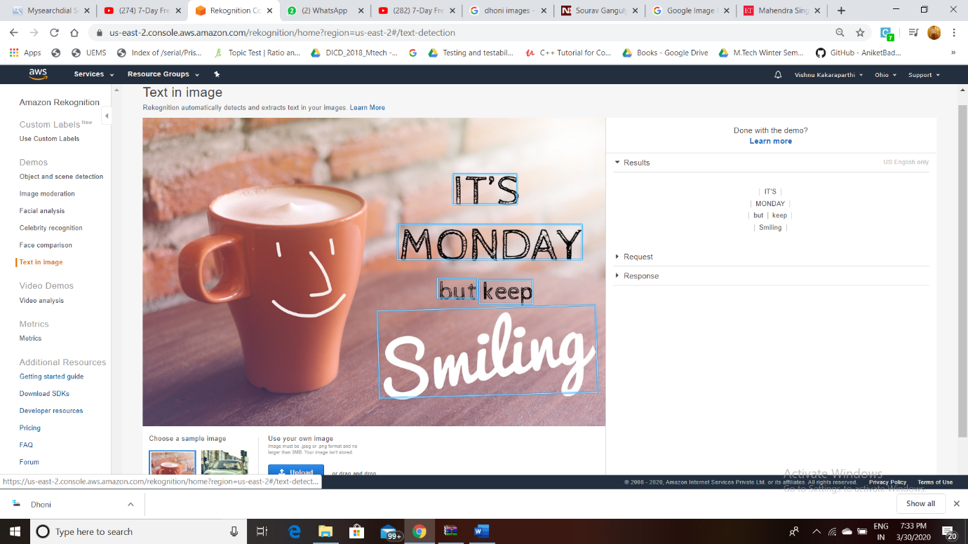

**PART5SCREENSHOTS (EC2 &S3):**

1. **INSTALLING AWS-SDK &php:**

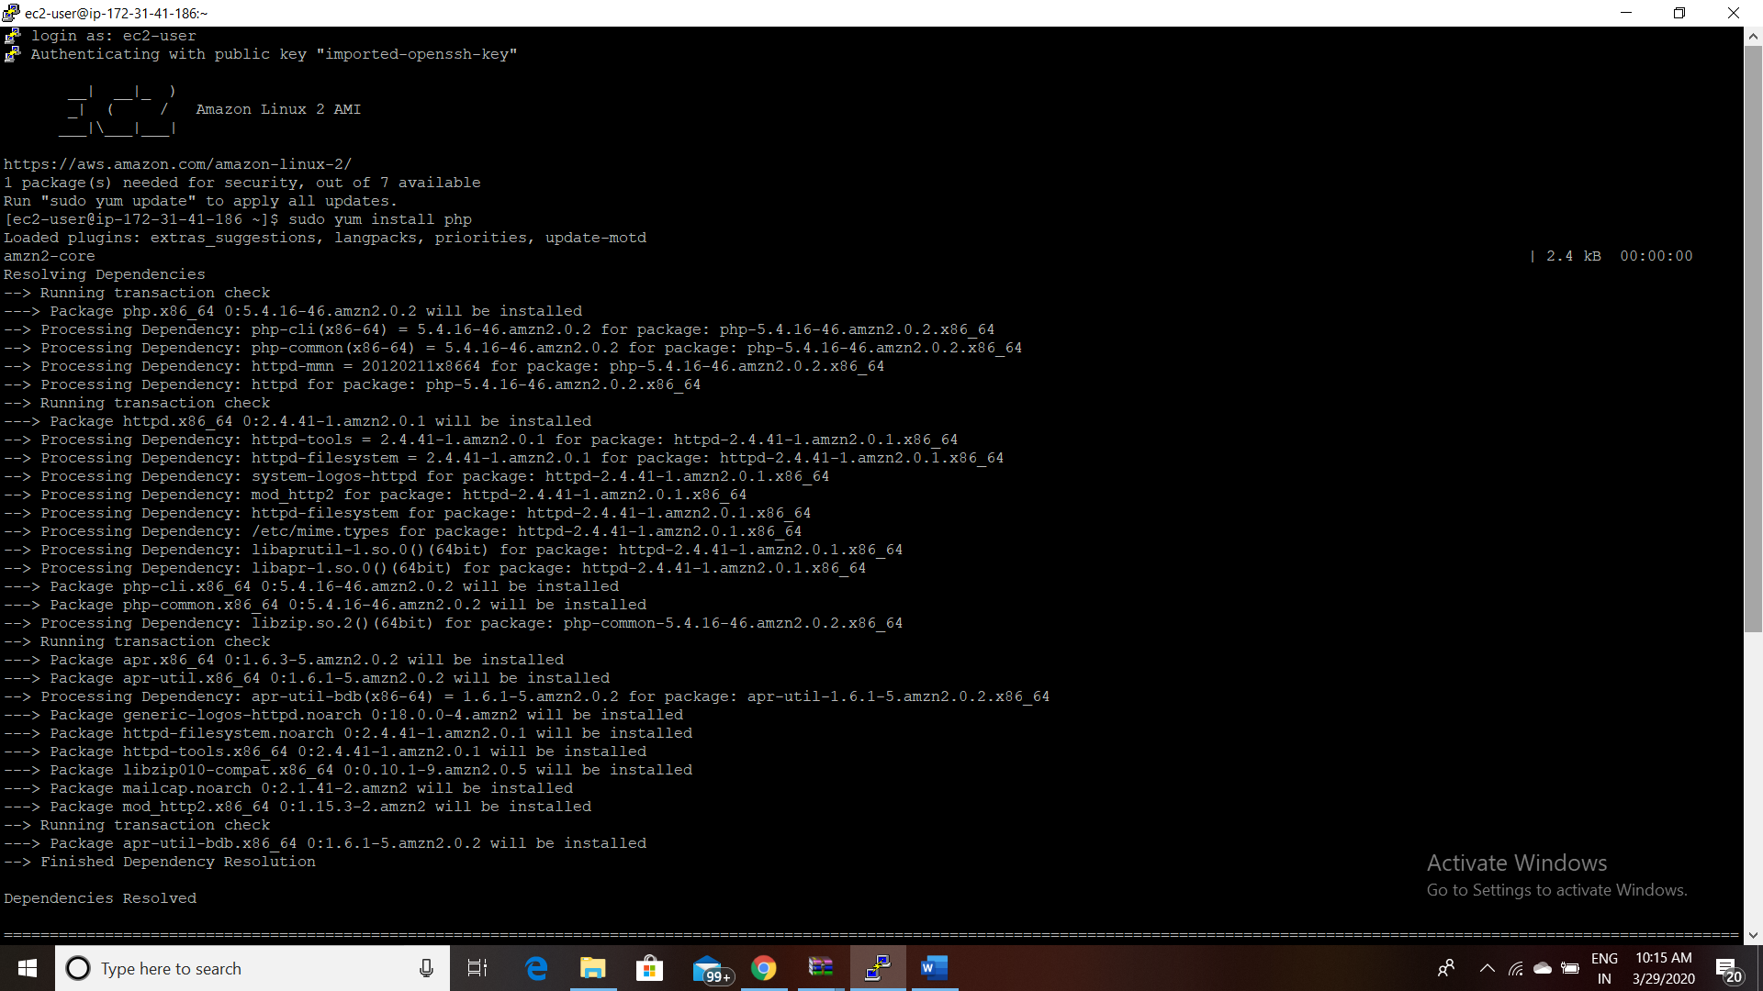

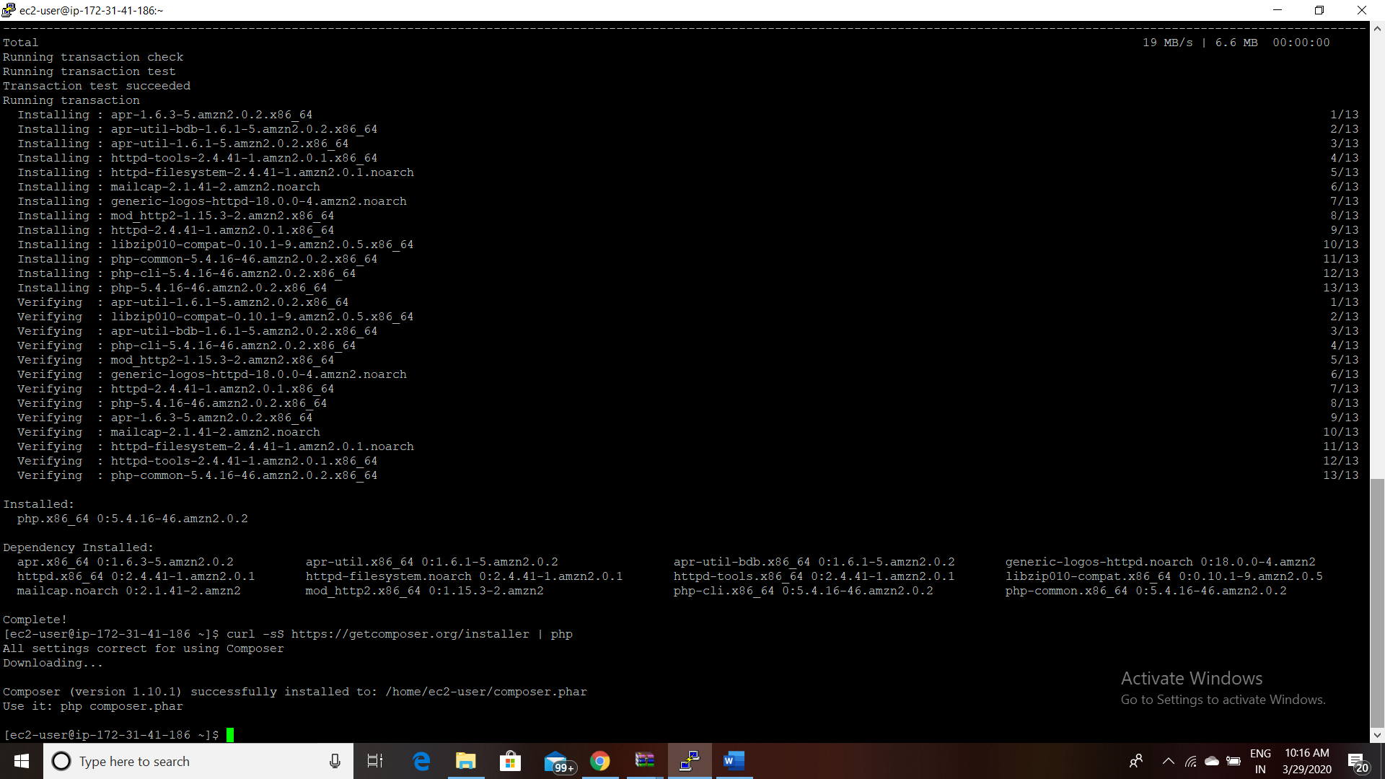

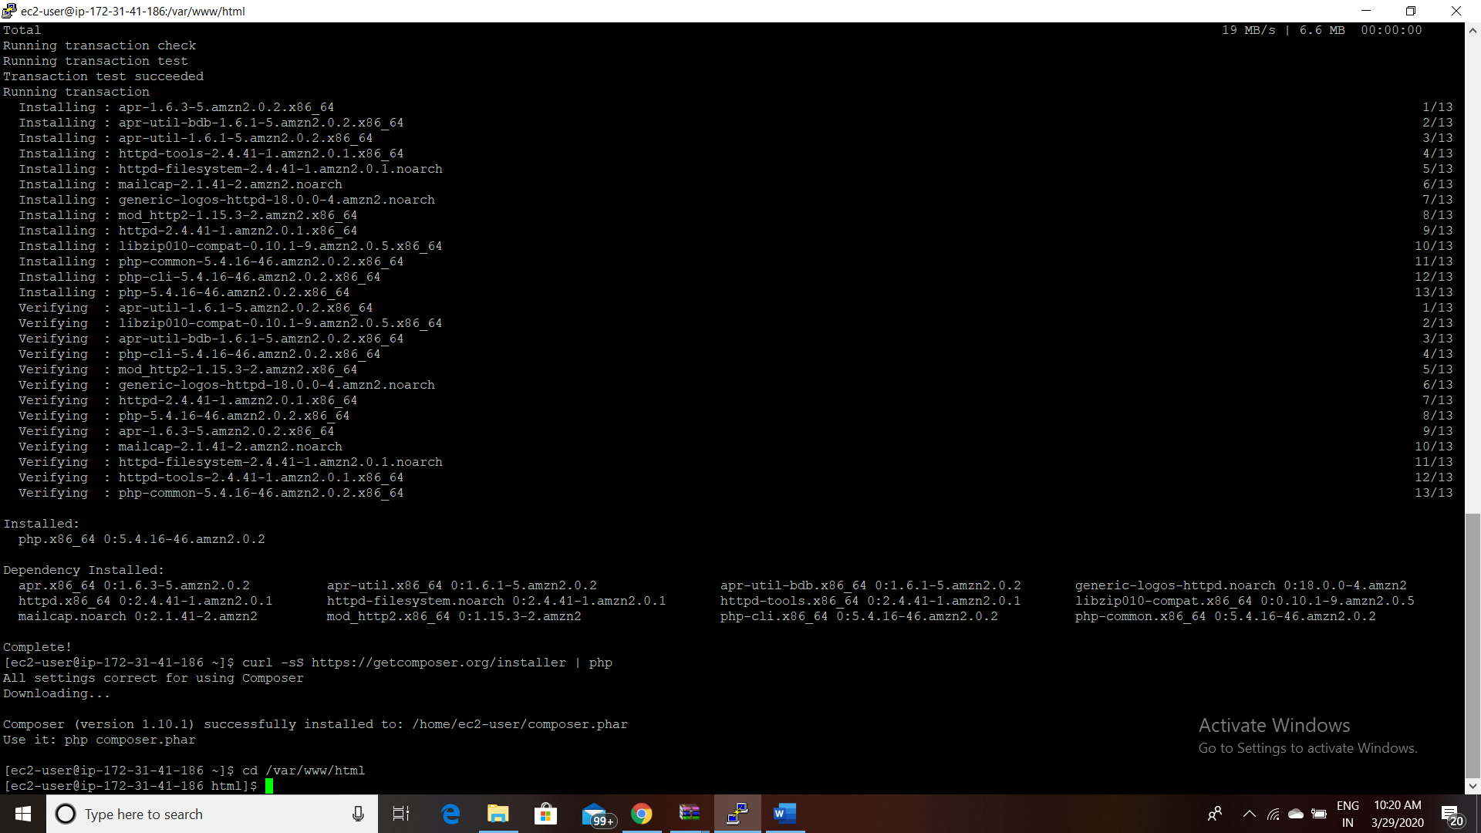

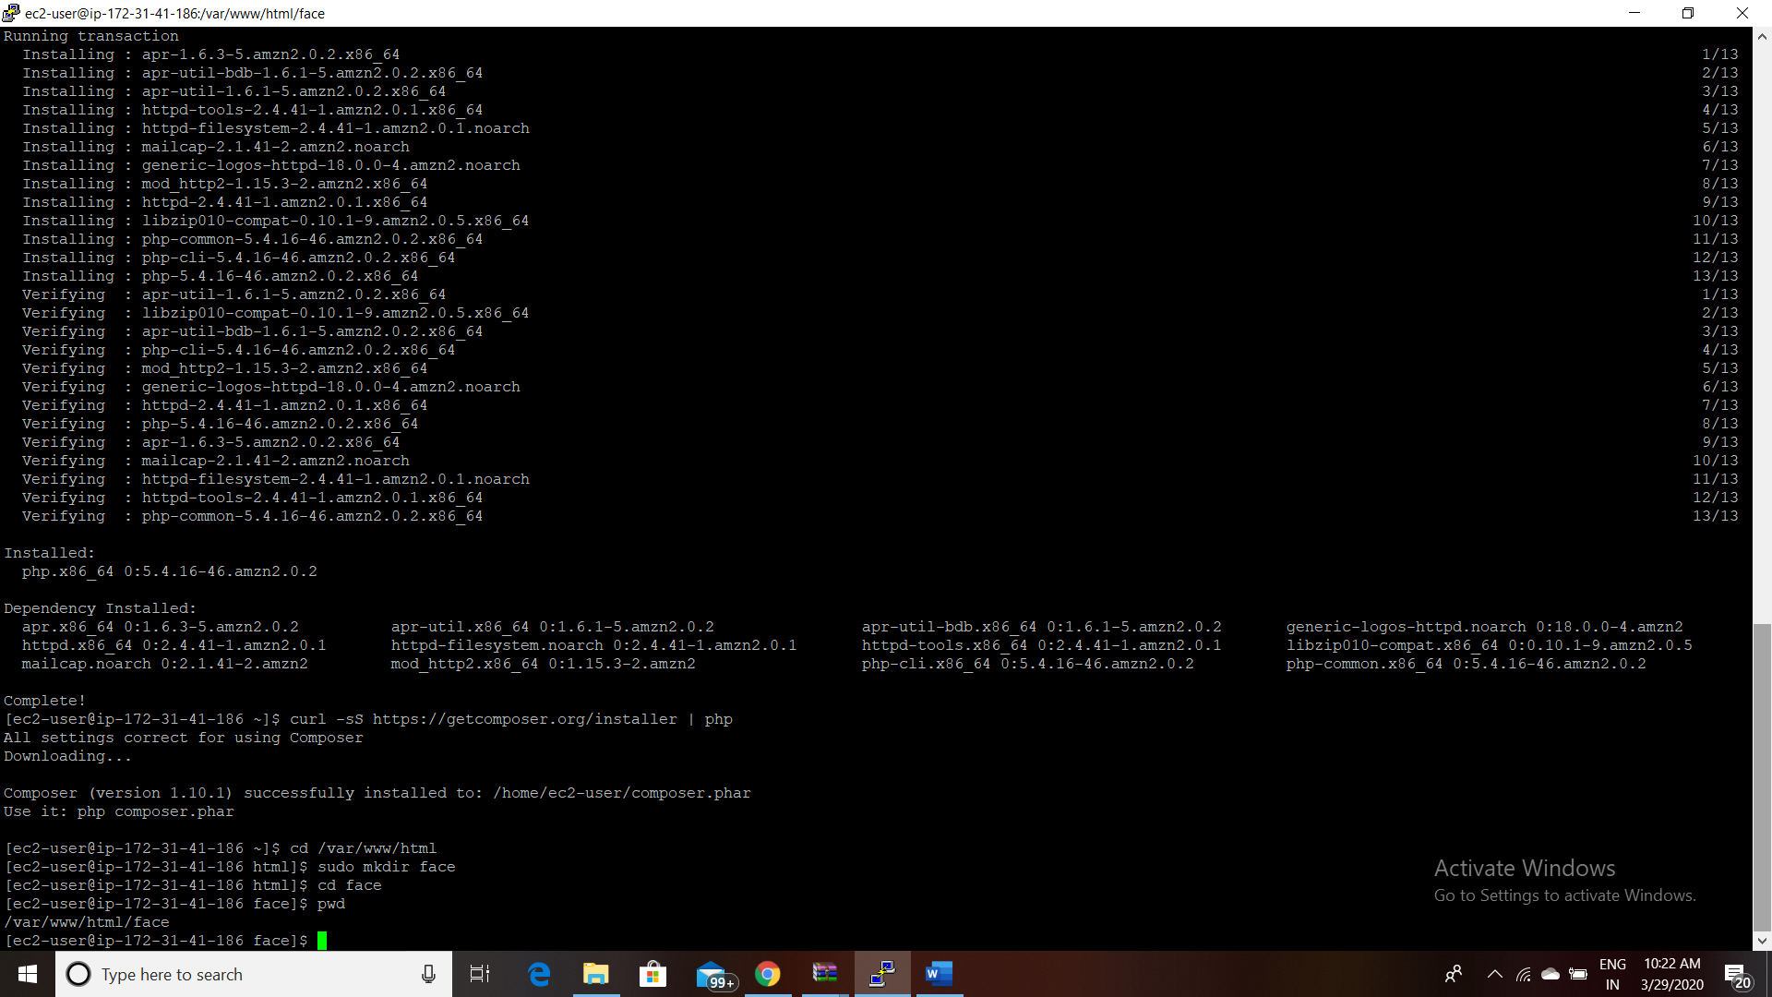

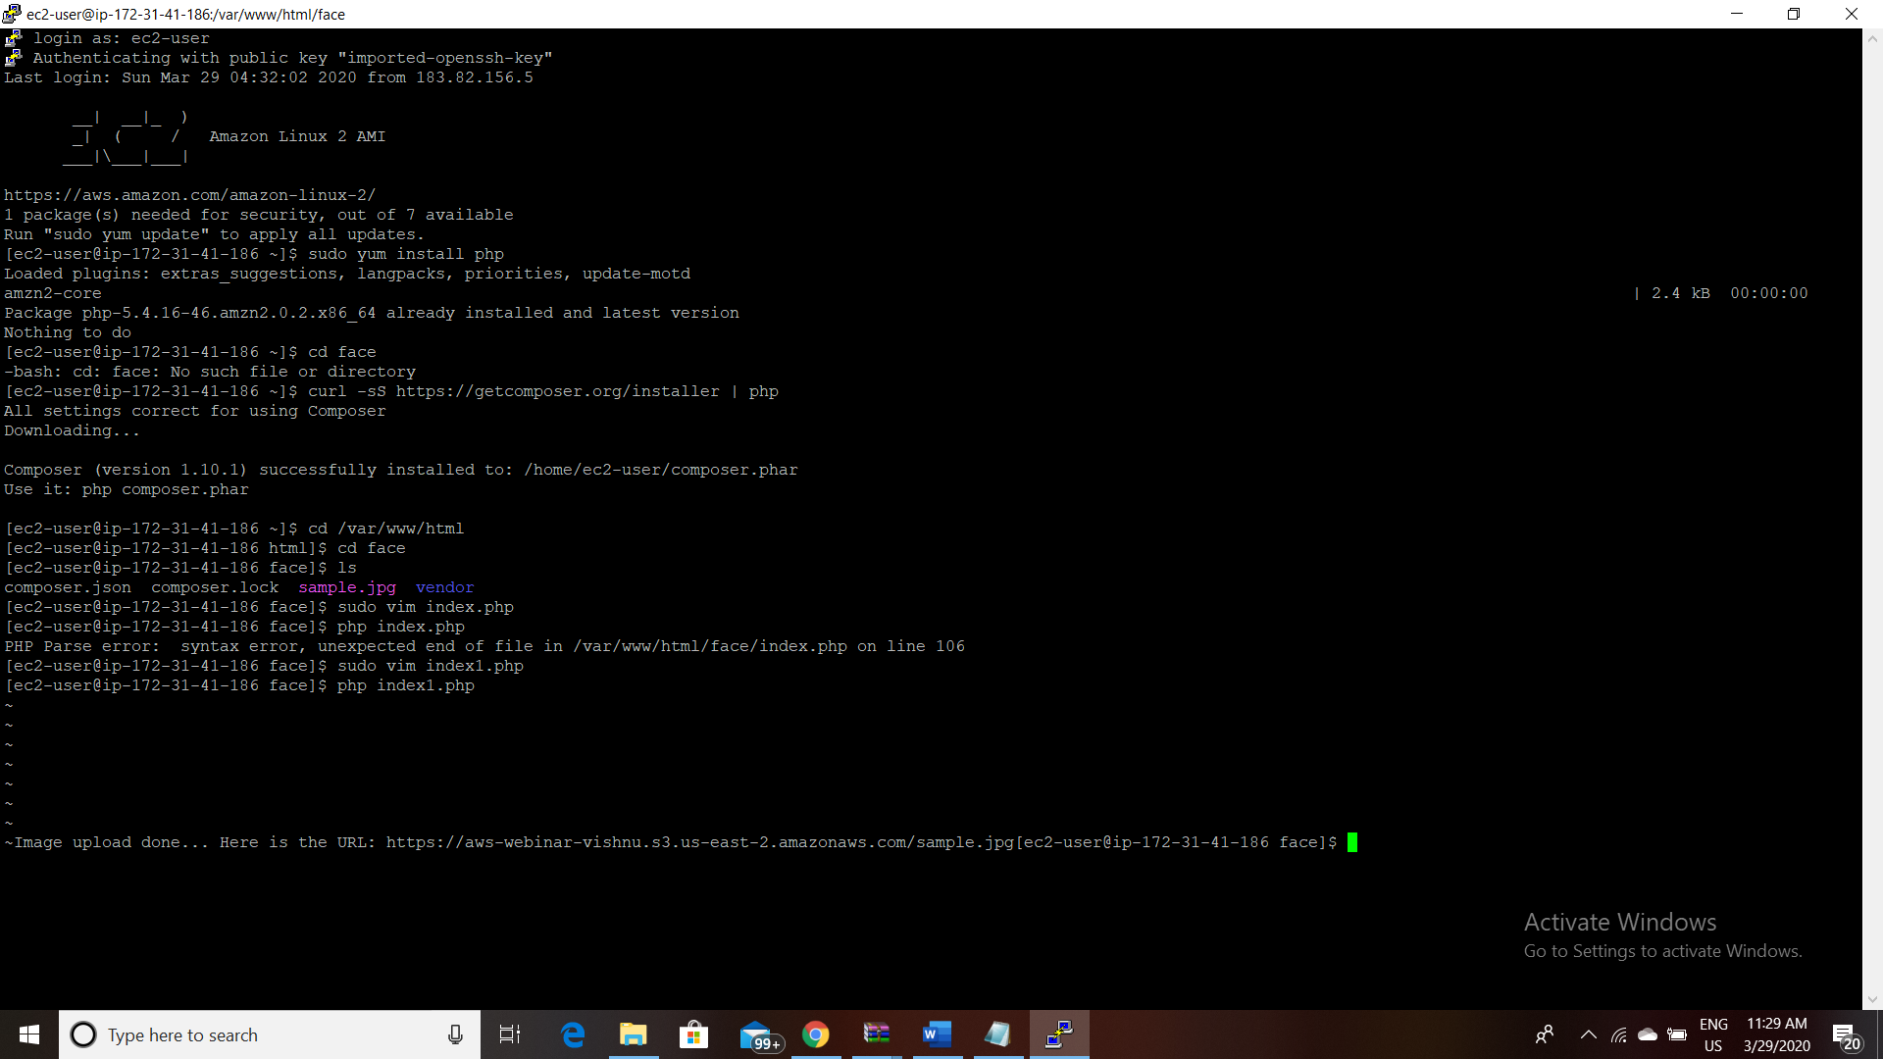

1. **Index.php file code:**

<?php

/*

Install php - sudo yum install php

curl -sS https://getcomposer.org/installer | php

cd /var/www/html

sudo mkdir face

cd face

sudo php -d memory_limit=-1 ~/composer.phar require aws/aws-sdk-php

In case if you get memory error -

sudo /bin/dd if=/dev/zero of=/var/swap.1 bs=1M count=1024

sudo /sbin/mkswap /var/swap.1

sudo /sbin/swapon /var/swap.1

sudo wget https://i.pinimg.com/originals/b9/7e/a3/b97ea33b5842c7894b804923c6c05580.jpg

sudo mv b97ea33b5842c7894b804923c6c05580.jpg sample.jpg

*/

error_reporting(0);

require_once(__DIR__ . '/vendor/autoload.php');

use Aws\S3\S3Client;

use Aws\Rekognition\RekognitionClient;

$bucket = 'aws-webinar-vishnu';

$keyname = 'sample.jpg';

$s3 = S3Client::factory([

'profile' => 'default',

'region' => 'us-east-2',

'version' => '2006-03-01',

'signature' => 'v4'

]);

try {

// Upload data.

$result = $s3->putObject([

'Bucket' => $bucket,

'Key' => $keyname,

'SourceFile' => __DIR__. "/$keyname",

'ACL' => 'public-read'

]);

// Print the URL to the object.

$imageUrl = $result['ObjectURL'];

if($imageUrl) {

echo "Image upload done... Here is the URL: " . $imageUrl;

}

} catch (Exception $e) {

echo $e->getMessage() . PHP_EOL;

}

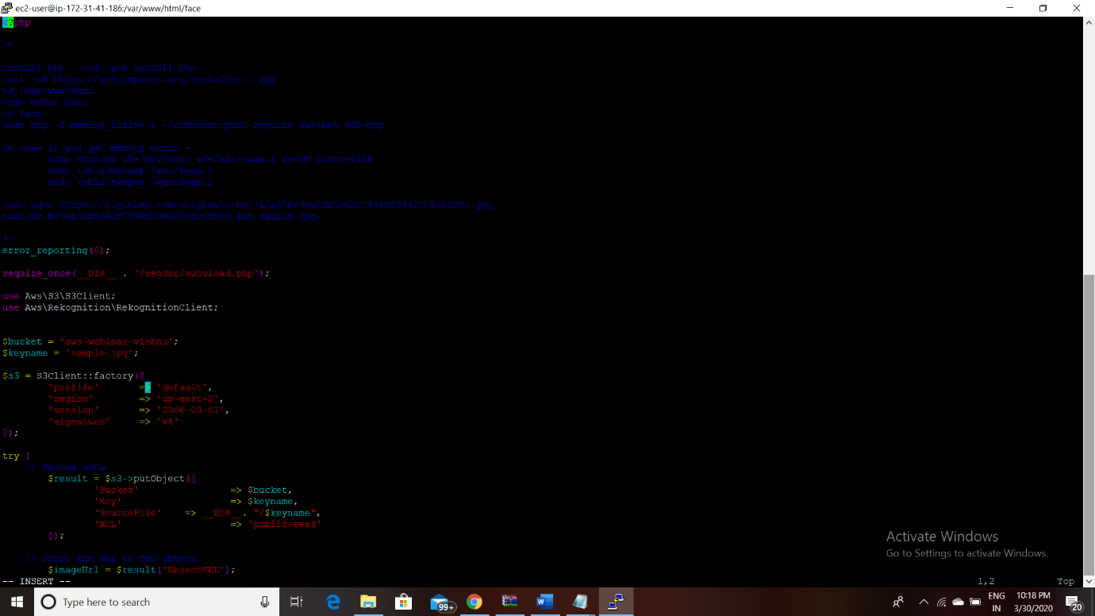

1. **Upload Success screenshot:**



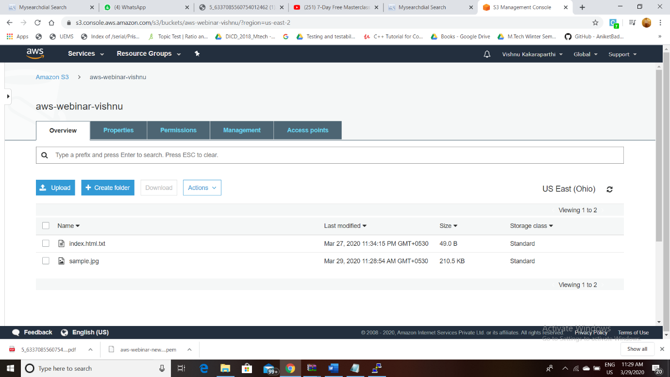



**Result: Thus an object is uploaded from EC2 and completed successfully.**

**EC2 & Rekognition:**

**FACE DETECT SUCCESS SCREENSHOT:**

**INDEX.php File code:**

<?php

/*

Install php - sudo yum install php

curl -sS https://getcomposer.org/installer | php

cd /var/www/html

sudo mkdir face

cd face

sudo php -d memory_limit=-1 ~/composer.phar require aws/aws-sdk-php

In case if you get memory error -

sudo /bin/dd if=/dev/zero of=/var/swap.1 bs=1M count=1024

sudo /sbin/mkswap /var/swap.1

sudo /sbin/swapon /var/swap.1

sudo wget https://i.pinimg.com/originals/b9/7e/a3/b97ea33b5842c7894b804923c6c05580.jpg

sudo mv b97ea33b5842c7894b804923c6c05580.jpg sample.jpg

Incase if you are getting any class NOT found error, follow these steps

sudo yum remove php*

sudo yum remove httpd*

sudo yum clean all

sudo yum upgrade -y

sudo amazon-linux-extras install php7.2

sudo yum install php-json php-xml php-cli php-mbstring

sudo yum install httpd

*/

// error_reporting(0);

require_once(__DIR__ . '/vendor/autoload.php');

use Aws\S3\S3Client;

use Aws\Rekognition\RekognitionClient;

$bucket = 'aws-webinar-vishnu';

$keyname = 'sample.jpg';

$s3 = new S3Client([

'region' => 'us-east-2',

'version' => '2006-03-01',

'signature' => 'v4'

]);

try {

// Upload data.

$result = $s3->putObject([

'Bucket' => $bucket,

'Key' => $keyname,

'SourceFile' => __DIR__. "/$keyname",

'ACL' => 'public-read-write'

]);

// Print the URL to the object.

$imageUrl = $result['ObjectURL'];

if($imageUrl) {

echo "Image upload done... Here is the URL: " . $imageUrl;

$rekognition = new RekognitionClient([

'region' => 'us-east-2',

'version' => 'latest',

]);

$result = $rekognition->detectFaces([

'Attributes' => ['DEFAULT'],

'Image' => [

'S3Object' => [

'Bucket' => $bucket,

'Name' => $keyname,

'Key' => $keyname,

],

],

]);

echo "Totally there are " . count($result["FaceDetails"]) . " faces";

}

} catch (Exception $e) {

echo $e->getMessage() . PHP_EOL;

}

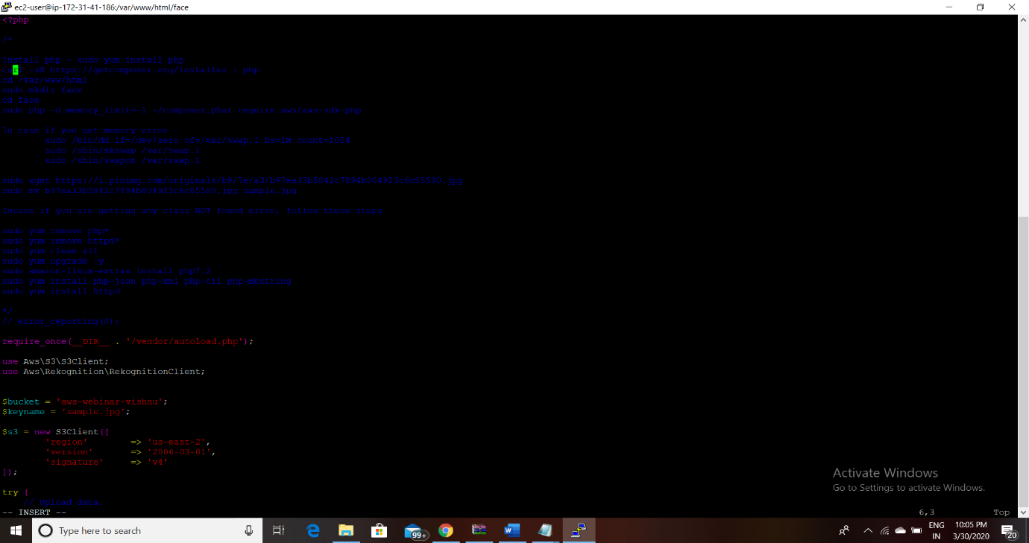

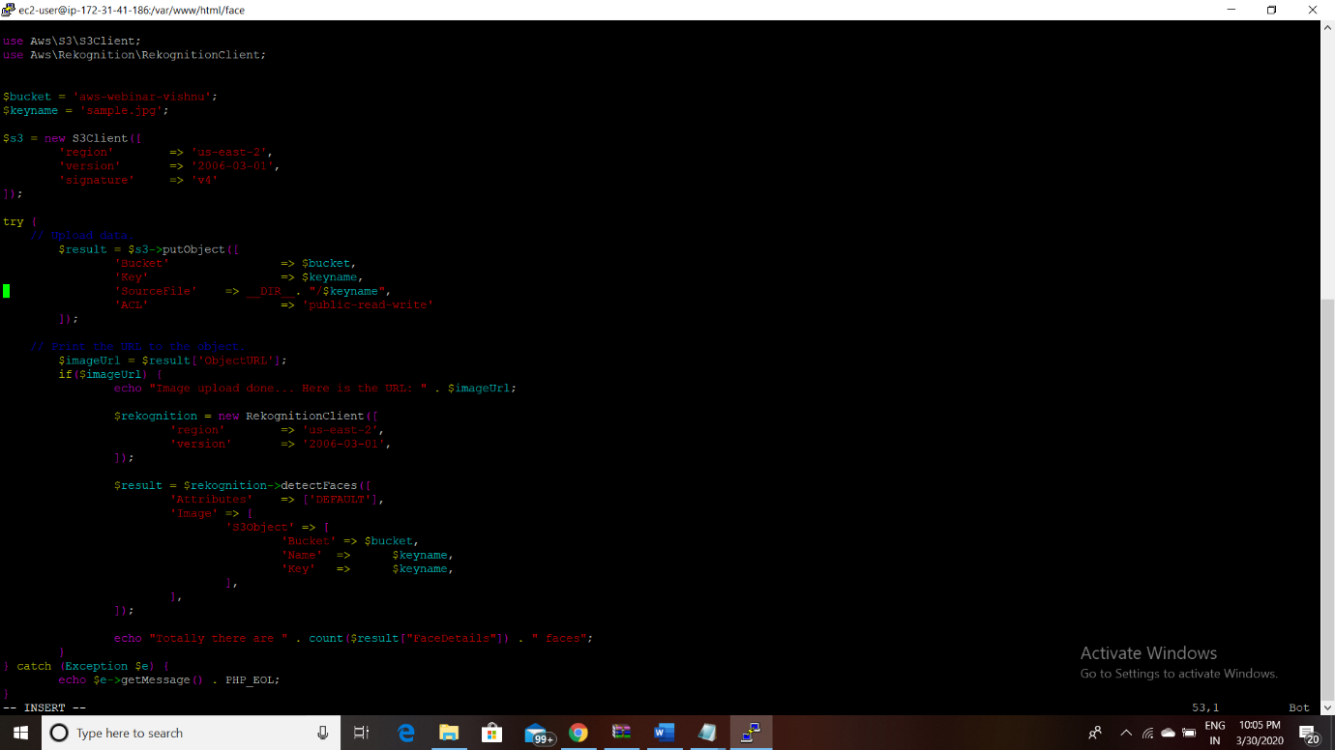

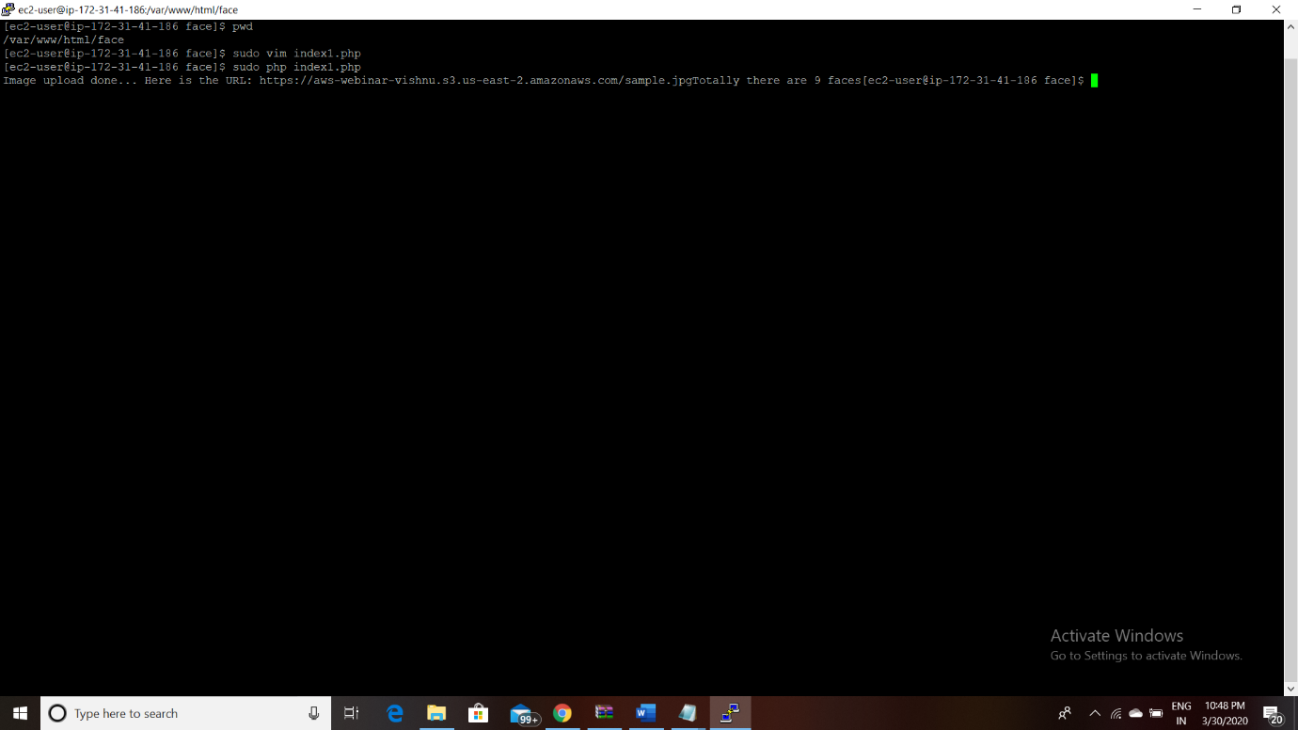

**RESULT :** HENCE BUILDING A FACE DETECTION APP ON AWS IS COMPLETED SUCCESSFULLY.